Phase III: Dashboard Implementation

*Submitted by*

[Naveen Kumar Manokaran](https://canvas.asu.edu/groups/607025/users/1076721)

“Ira A. Fulton Schools of Engineering, Arizona State University”

“IFT 533: data Visualization”

(2024 Fall)

*Submitted to:* Prof. Asmaa Elbadrawy

Submitted on: December 1st, 2024.

**Index**

|  |  |  |
| --- | --- | --- |
| **S. No** | **Title** | **Page No** |
| **1** | **Section1: The Dashboard**   1. **Business Problem** 2. **Solution with Dashboard** | **3**  **4**  **4** |
| **2** | **Section 2: The Dataset** | **6** |
| **3** | **Section 3: Dashboard Users** | **15** |
| **4** | **Section 4: Questions** | **18** |
| **5** | **Section 5:** **Plots** | **19** |
| **6** | **Section 6: Interactivity** | **30** |
| **7** | **Section 7: References** | **39** |

**SECTION 1: The Dashboard**

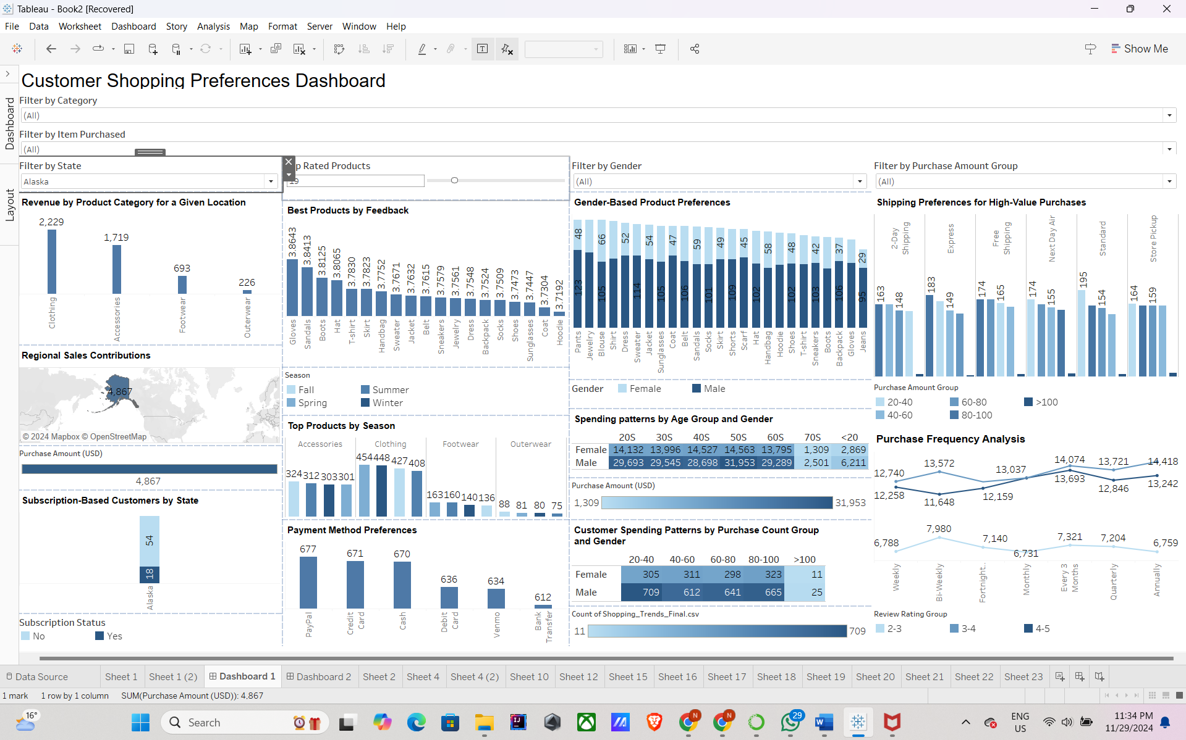

The dashboard above provides a detailed analysis of customer purchasing preferences, allowing stakeholders to gain insight into critical aspects of retail business performance such as sales trends, customer demographics, and product popularity. It uses transaction data to disclose information on state-specific revenue contributions, gender-based product preferences, and seasonal demand trends. The dashboard shows the best-performing goods based on feedback, spending habits across age groups, and preferred payment methods, providing a detailed understanding of customer behavior. Furthermore, it displays data on subscription-based consumers and their distribution among states, as well as shipping preferences for high-value orders. The availability of interactive filters such as category, item purchased, gender, and purchase amount group enables users to delve down into specific client categories and adjust their study accordingly.

This dashboard also highlights crucial indicators such as buy frequency trends, spending patterns based on purchase count and demographics, and product feedback ratings, which may be used to promote customer satisfaction and loyalty. Its broad set of visualizations, which include bar charts, heatmaps, line charts, and geographical maps, provide a comprehensive picture of consumer interactions and operational performance. By combining this information, the dashboard enables data-driven decision-making in areas such as inventory planning, marketing tactics, and pricing modifications. It finally serves as an effective tool for identifying growth prospects, optimizing corporate operations, and ensuring long-term profitability in the competitive retail sector.

**Creating a Story:**

1. **Business Problem: Identifying and Addressing Declining Sales in Specific Product Categories Across Demographics**

In some client segments (e.g., particular age groups, genders, or geographic places), a retail corporation observes a drop in sales for particular product categories, such apparel or accessories. The company finds it difficult to identify the precise causes of the drop, such as shifting consumer tastes, poor advertising campaigns, or poor inventory management. The business runs the risk of losing market share and profitability in the absence of clear insights.

1. **Solution Using the Dashboard**

The described dashboard provides powerful insights that can be used to address this issue:

1. **Examine Product Popularity by Population :**
   1. To determine which goods in a given category are doing best and worst, use interactive filters.
   2. Analyze sales patterns according to the region, gender, and age of your customers. Examine whether younger consumers are switching between categories, for instance, or whether some states are contributing less to the national total.
2. **Assess the Effects of Promotions and Discounts:**
   1. To find out if marketing activities are failing or aiming at the incorrect demographic, examine data on discounts and promo codes used.
   2. Analyze past campaigns' efficacy by contrasting sales patterns during promotional times.
3. **Evaluate Ratings and Comments from Customers** 
   1. Analyze reviews of underperforming items to find trends in customer discontent.
   2. Low ratings for particular goods or categories could be a hint of problems with design or quality.
4. **Examine Shipping Preferences and Seasonal Demand** 
   1. To ascertain whether demand for particular products varies more than anticipated, identify seasonal trends.
   2. To enhance the shopping experience for devoted clients, review shipping preferences for expensive orders.
5. **Optimize Marketing and Inventory Plans** 
   1. Reallocate stock to areas with high demand and modify inventory levels for underperforming products in light of the analysis.
   2. Tailor marketing tactics to appeal to particular groups, for as emphasizing eco-friendly items to draw in environmentally sensitive consumers or using internet advertisements to target younger consumers.

**SECTION 2: The Dataset:**

**Dataset Name**: Customer Shopping Preferences Dataset

**Description**:

The Customer Shopping Preferences Dataset provides useful information about consumer behavior and purchasing habits. It provides information about customer demographics, product preferences, purchasing history, and transaction details, allowing firms to customize their strategies efficiently. Understanding customers' preferences is critical for optimizing product offers, boosting marketing campaigns, and increasing customer happiness.  
This dataset contains 3,900 records with variables including age, gender, purchase amount, and frequency of purchases. It also maintains product-specific information such as category, size, color, and seasonal patterns. It also contains feedback ratings and information about promotional deals. Designed as a synthetic dataset, it provides a realistic environment for learning data analysis and machine learning without jeopardizing sensitive personal information.

The dataset offers a starting point for creating data-driven insights that may be applied to improve consumer experiences, expedite processes, and strengthen decision-making. Retail managers, marketing experts, and customer experience teams are among the stakeholders it serves, and it provides a chance to examine and forecast consumer purchasing patterns.

**Acknowledgement:**

This dataset was created artificially using ChatGPT to mimic a genuine consumer shopping experience. Its goal is to give novices and data aficionados a platform where they can develop, enjoy, practice, and learn from a dataset that replicates actual consumer purchasing behavior. A deeper comprehension of data analysis and interpretation in relation to customer preferences and retail scenarios is intended by promoting learning and experimentation in a simulated environment.

**Dataset Attributes**

1. **Customer ID**
   1. **Description**: Unique identifier for each customer.
   2. **Type**: Categorical
   3. **Domain**: 1 to 3900
2. **Age**
   1. **Description**: Age of the customer.
   2. **Type**: Ratio
   3. **Domain**: 18 to 70
3. **Gender**
   1. **Description**: Gender of the customer (Male/Female).
   2. **Type**: Categorical
   3. **Domain**: Male, Female
4. **Item Purchased**
   1. **Description**: Name of the item purchased.
   2. **Type**: Categorical
   3. **Domain**: Examples include Blouse, Pants
5. **Category**
   1. **Description**: Category of the item purchased (e.g., Clothing, Footwear).
   2. **Type**: Categorical
   3. **Domain**: Examples include Clothing, Footwear, Accessories
6. **Purchase Amount (USD)**
   1. **Description**: Amount spent by the customer in USD.
   2. **Type**: Ratio
   3. **Domain**: $20 to $100
7. **Location**
   1. **Description**: Geographic location of the customer.
   2. **Type**: Categorical
   3. **Domain**: Examples include Montana, California
8. **Size**
   1. **Description**: Size of the purchased item.
   2. **Type**: Categorical
   3. **Domain**: S, M, L, XL
9. **Color**
   1. **Description**: Color of the purchased item.
   2. **Type**: Categorical
   3. **Domain**: Examples include Olive, Yellow
10. **Season**
    1. **Description**: Season during which the purchase was made.
    2. **Type**: Categorical
    3. **Domain**: Spring, Summer, Fall, Winter
11. **Review Rating**
    1. **Description**: Customer’s rating for the purchased item (scale: 2.5 to 5.0).
    2. **Type**: Ratio
    3. **Domain**: 2.5 to 5.0
12. **Subscription Status**
    1. **Description**: Indicates if the customer has a subscription (Yes/No).
    2. **Type**: Categorical
    3. **Domain**: True, False
13. **Shipping Type**
    1. **Description**: Type of shipping selected by the customer.
    2. **Type**: Categorical
    3. **Domain**: Examples include Free Shipping, Standard
14. **Discount Applied**
    1. **Description**: Indicates whether a discount was applied to the purchase.
    2. **Type**: Categorical
    3. **Domain**: True, False
15. **Promo Code Used**
    1. **Description**: Indicates if a promo code was used for the purchase.
    2. **Type**: Categorical
    3. **Domain**: True, False
16. **Previous Purchases**
    1. **Description**: Total number of prior purchases made by the customer.
    2. **Type**: Ratio
    3. **Domain**: 1 to 50
17. **Preferred Payment Method**
    1. **Description**: Most frequently used payment method by the customer.
    2. **Type**: Categorical
    3. **Domain**: Examples include PayPal, Credit Card
18. **Frequency of Purchases**
    1. **Description**: How often the customer makes purchases.
    2. **Type**: Categorical
    3. **Domain**: Examples include Weekly, Monthly

**Dataset Screenshot:**

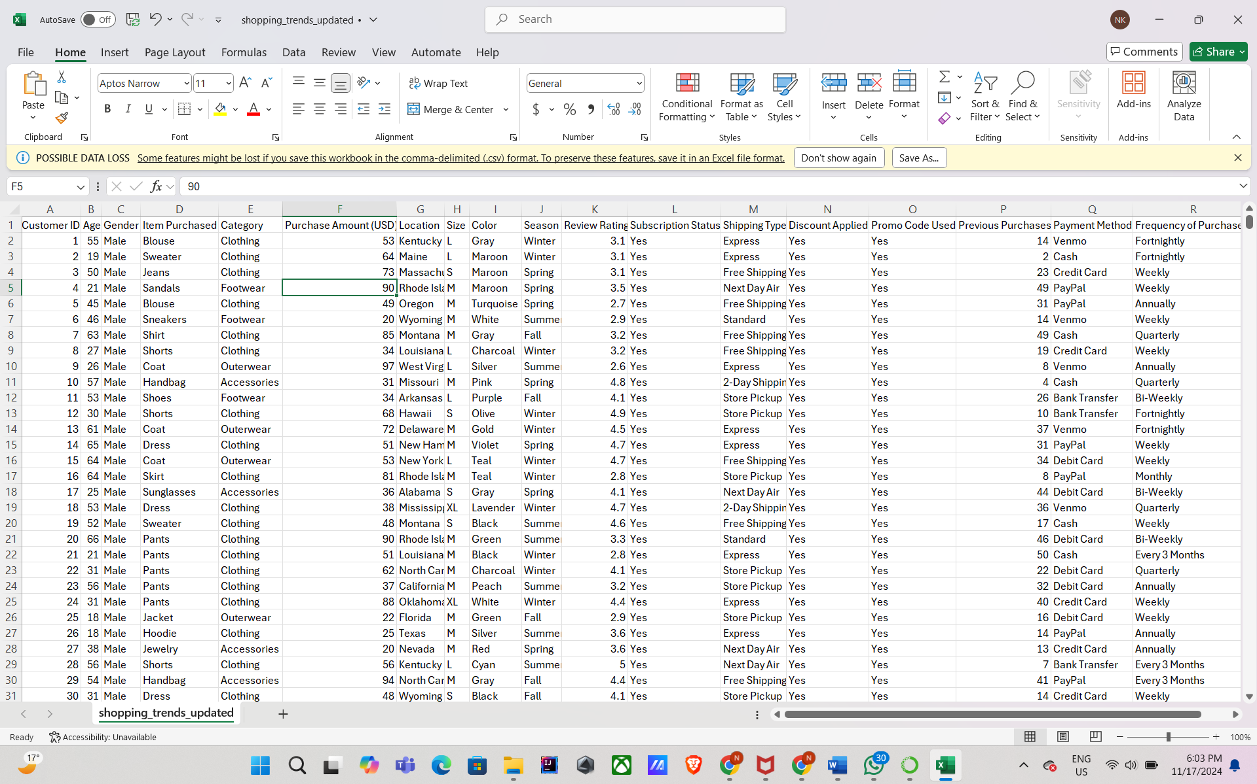

**Dataset Preprocessing:**

This Dataset requires only minimal preprocessing since the dataset was already cleaned. The Dataset did not have any null values or missing datapoints. Using **Tableau Prep Builder**, we created calculated fields to group data for enhanced clarity and usability:

**Age Group:** Categorized into logical segments:

<20, 20s, 30s, 40s, 50s, 60s, 70s.

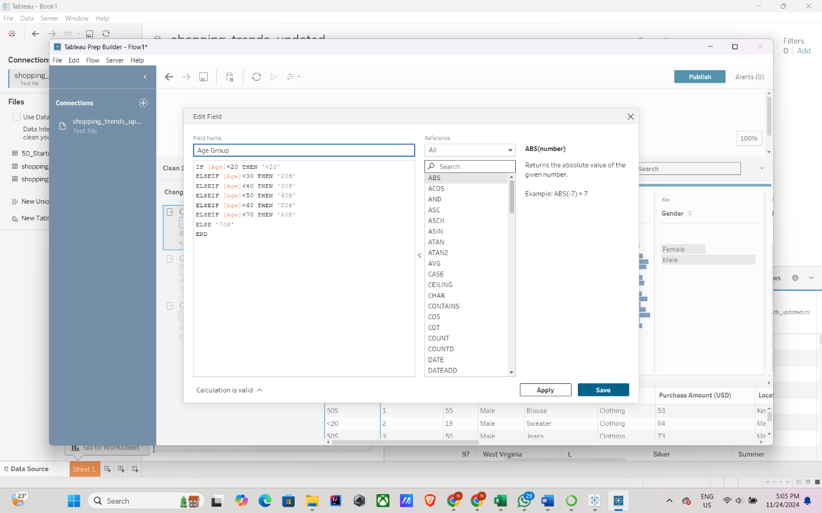

**Purchase Amount Group:** Grouped by ranges:

20-40, 40-60, 60-80, 80-100, 100+.

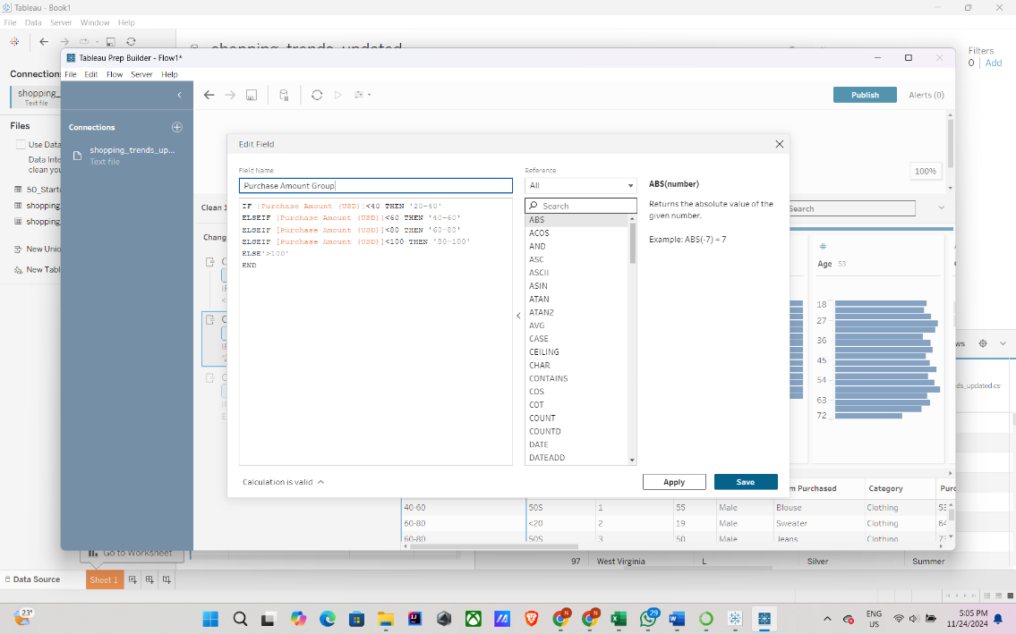

**Review Rating Group:** Segmented into intervals: 1-2, 2-3, 3-4, 4-5.

These calculated fields improve analysis by organizing data into meaningful categories, making the dashboard more intuitive and insightful for users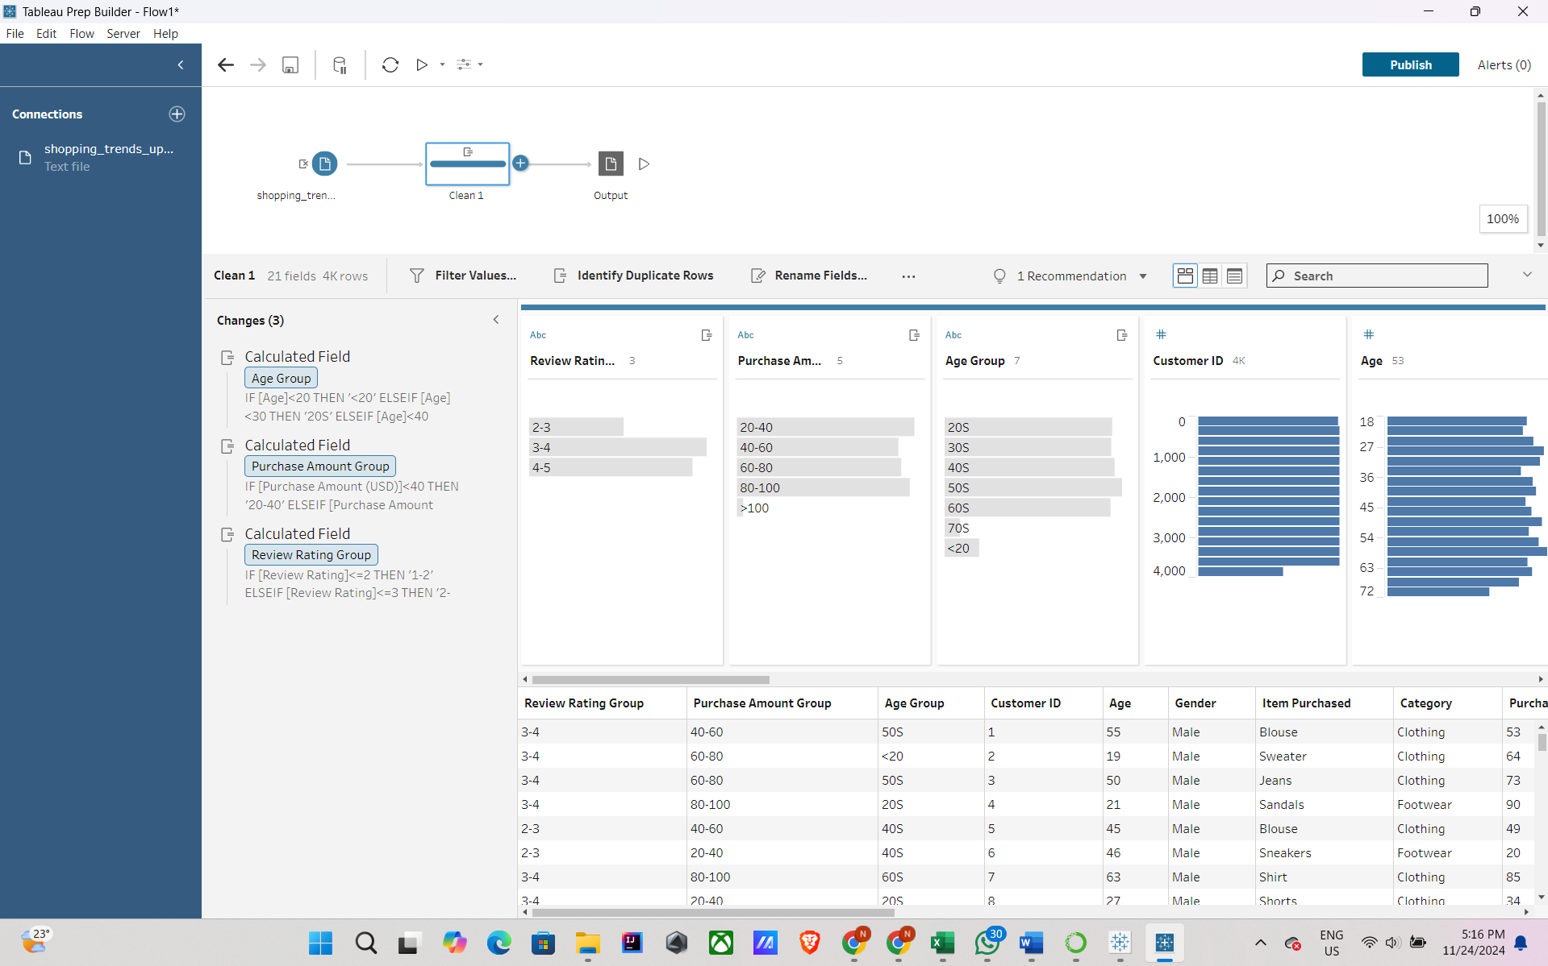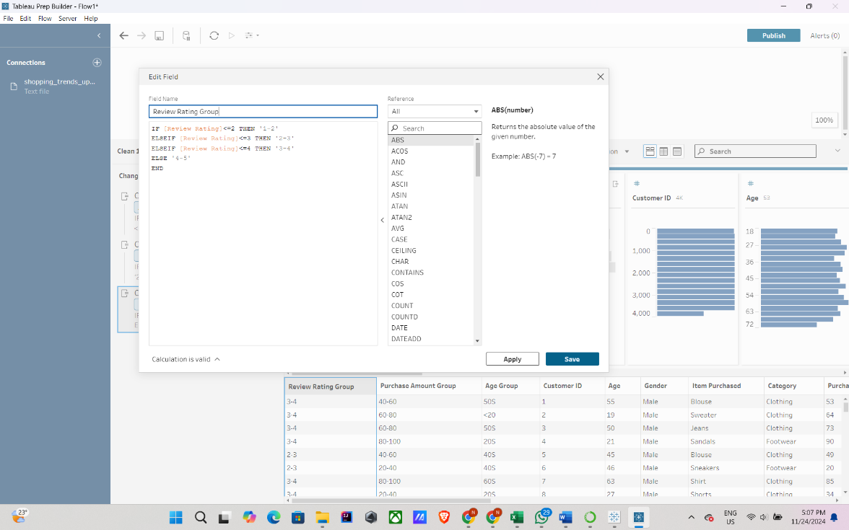.

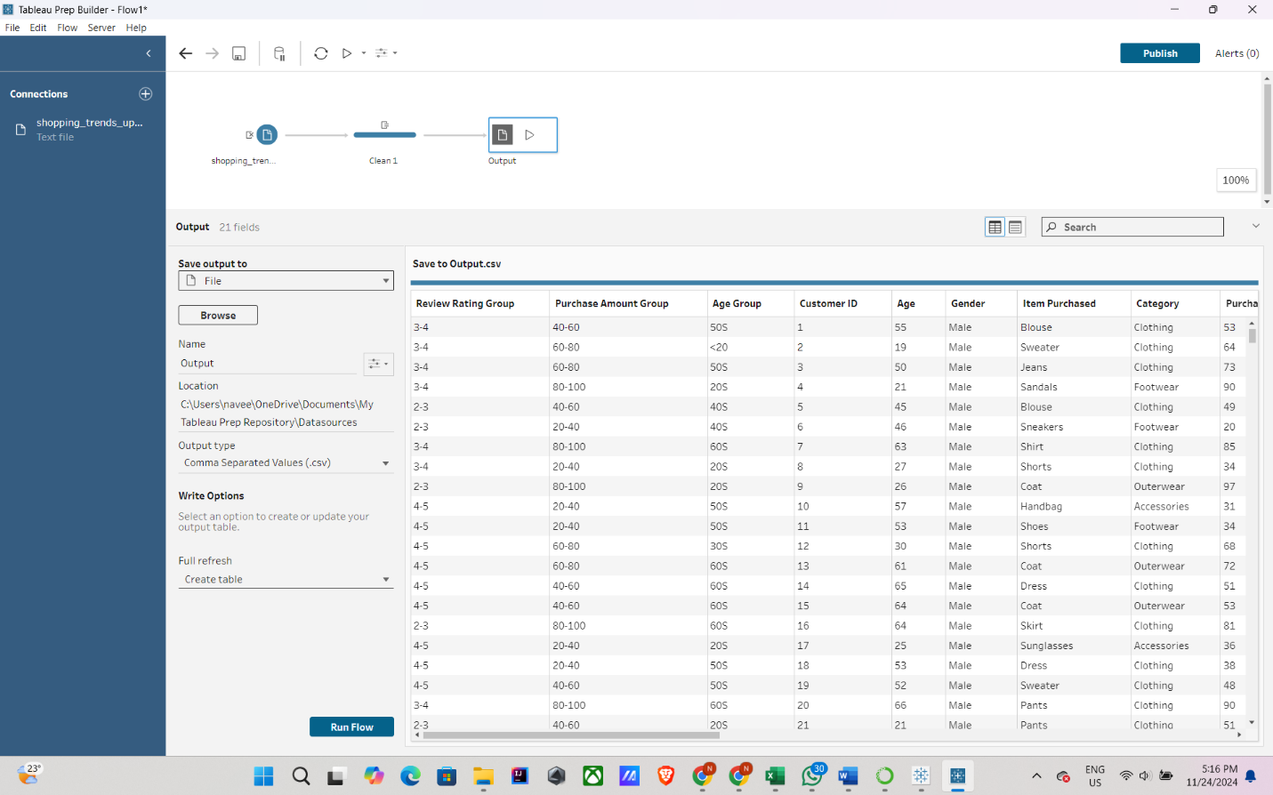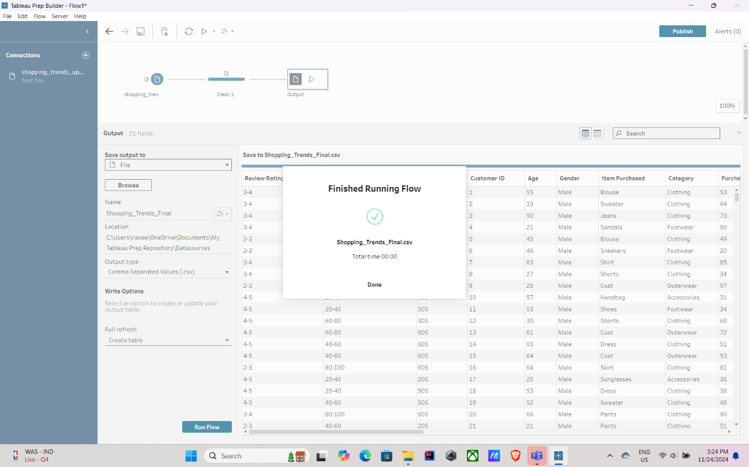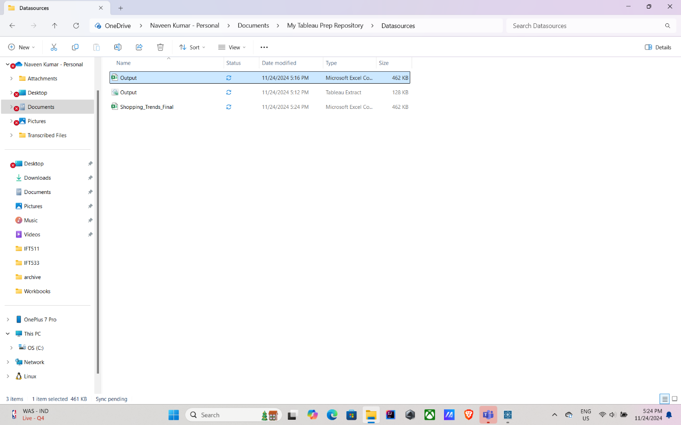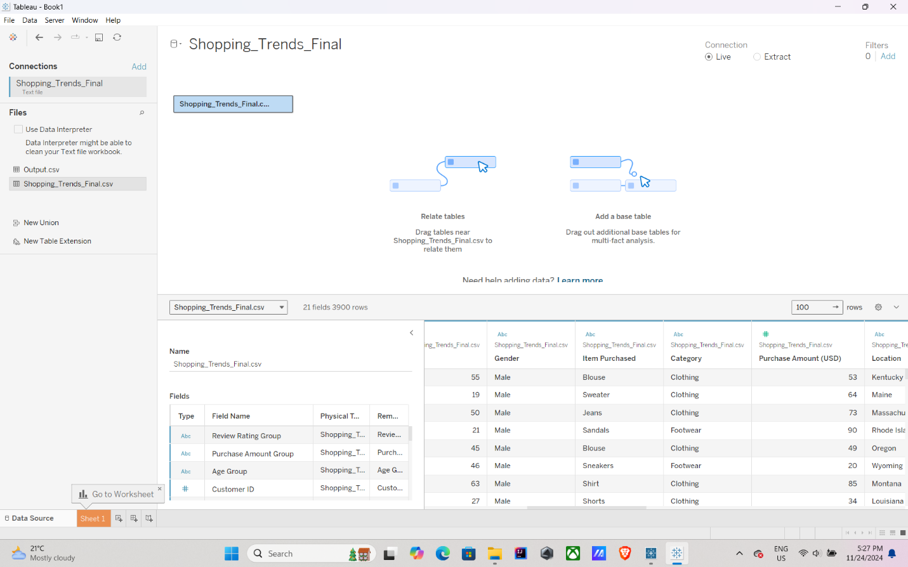

**Section 3: Dashboard Users**

1. **Retail Business Managers**
   * **Purpose**: Retail business managers are in charge of attaining sales goals and supervising store operations. They may monitor sales performance across several product categories, regions, and time periods with the aid of a dashboard.
   * **Usage**: They are able to spot slow-moving items, track sales patterns in real time, and effectively manage inventory to satisfy demand. They are also able to evaluate how advertising efforts affect total sales.
2. **Marketing Teams**
   * **Purpose:** The goal of marketing teams' tailored campaigns is to boost sales and encourage consumer interaction.
   * **Usage:** They may examine consumer demographics, purchasing patterns, and the outcomes of promotional efforts thanks to dashboards. To optimize returns on marketing investment, they can determine which campaigns are most effective for particular client segments, such as age or geography, and modify their approaches appropriately.
3. **Customer Experience Teams**
   * **Purpose**: The goal of these teams is to increase client pleasure and foster loyalty.
   * **Usage**: The dashboard assists them in measuring client happiness, tracking feedback through review ratings, and comprehending customer preferences. Strategies to improve the shopping experience, including better product recommendations or expediting the checkout process, can be developed with the use of insights about common complaints or preferences.
4. **Product Development Teams**
   * **Purpose:** The goal of these teams is to develop or enhance products in response to consumer demand.
   * **Usage**: They can examine statistics on popular product attributes like size, color, or preferred categories using the dashboard. This ensures greater market fit and increased sales by assisting in the identification of trends and the development of new items that meet consumer wants.
5. **E-commerce Platform Managers**
   * **Purpose**: The goal of e-commerce administrators is to supervise the online channels through which transactions take place. Enhancing user experience and increasing online revenue are their two main objectives.
   * **Usage**: They may monitor consumer preferences, conversion rates, and website traffic thanks to dashboards. They can make adjustments that enhance the online shopping experience and increase sales by examining data on delivery options, preferred payment methods, and cart abandonment rates.
6. **Data Analysts**
   * **Purpose**: The goal of data analysts is to glean insights from unprocessed data in order to inform business choices.\
   * **Usage**: They do in-depth research on trend analysis, consumer segmentation, and purchasing trends using dashboards. Their research can be used to improve operations, develop company plans, and locate new growth prospects.
7. **Financial Analysts**
   * **Purpose**: The goal of financial analysts is to assess the company's financial health with an emphasis on cost control and profitability.
   * **Usage**: They keep an eye on spending trends, revenue sources, and the financial effects of sales and promotions by using dashboards. This aids in their ability to project future earnings and pinpoint areas where expenses can be cut without sacrificing product quality or client happiness.
8. **Supply Chain Managers**
   * **Purpose**: The goal of supply chain managers is to guarantee the smooth movement of commodities from suppliers to consumers.
   * **Usage**: Dashboards offer information on demand projections, inventory levels, and logistical efficiency. In order to guarantee that goods are accessible when and where customers need them, supply chain managers can minimize surplus inventory, cut down on stockouts, and expedite delivery times by examining these KPIs.
9. **Corporate Wellness Managers**
   * **Purpose**: The goal of these managers is to support workers' health and welfare in work settings.
   * **Usage**: They can use the dashboard to find patterns in employee buying habits, like how frequently they buy health-related products. The design of wellness programs that address the needs of employees, including encouraging better lifestyles through focused product discounts or workplace efforts, might be influenced by this data.
10. **App Developers**
    * **Purpose**: The goal of app developers is to produce digital tools that improve user experiences across a range of domains, such as lifestyle and fitness.
    * **Usage**: App developers can incorporate tailored suggestions for customers, such fitness or health advice depending on user behavior, by utilizing dashboard data. For instance, the app might recommend relevant products or activities if the data shows that users enjoy particular product categories during particular seasons, increasing user pleasure and engagement.

**SECTION 4: Questions**

The dashboard will address the following key questions to provide actionable insights:

1. Which product categories generate the highest revenue for the given location?
2. What are the top categories sold for a given season?
3. Which regions contribute most to total sales?
4. What are the top 5 best products as per customer feedback?
5. Which payment method is the most preferred by the customers?
6. What are the customer spending pattern for different age group and Gender?
7. What are the highest-selling products based on gender?
8. Which shipping types are preferred for high-value purchases?
9. Which states have the highest subscription-based customers?
10. How do customer purchase patterns vary based on frequency of purchases?
11. How do review ratings correlate with purchase amounts?
12. What are the spending habits of customers with high purchase counts?
13. Which age group Customer spends the most?
14. Customer in which gender spends the most?
15. Does the review of the products affect the frequency of purchase?

**SECTION 5: Plots**

**PLOT 1: "Revenue by Product Category for a Given Location"**

**Chart Type**: Bar Chart  
**Rows**: SUM(Purchase Amount(USD))  
**Column**: Category  
**Filters**: State Select (Calculated Filter):True, Filter by State (Parameter)   
**Pre-attentive Attributes**: Length  
**Description**: Addresses Question 1 by showing total revenue generated by product categories for the selected location. The location can also be all giving the total revenue generated for each category.  
**Connected Questions**: 1

**Changes done as Professor suggested:** Ordered the graphs in descending order and in the edit, axis set Include zero to false so that the axis does not start from 0 and difference between the element values are more visible.

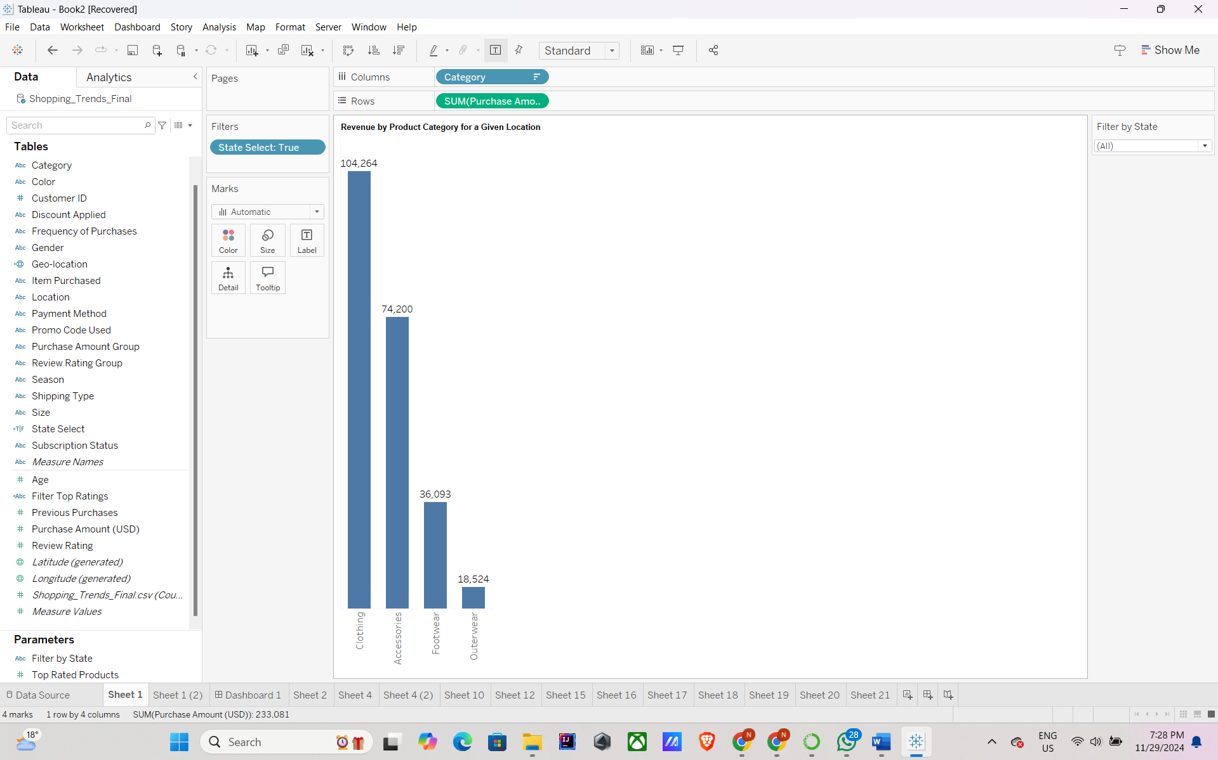

**PLOT 2: "Top Categories by Season"**

**Chart Type**: Stacked Bar Chart  
**Rows**: COUNT(Shopping_Trends_Final.csv)  
**Column**: Season  
**Marks Color Card**: Category  
**Pre-attentive Attributes**: Length, Position, Color  
**Color Distribution**: Distinct colors for each category  
**Description**: Addresses Question 2 by highlighting seasonal trends for top-selling categories.  
**Connected Questions**: 2

**Changes done as Professor suggested:** Ordered the graphs in descending order and changed the graph from stacked bar chart to multi series bar chart to better represent the data.

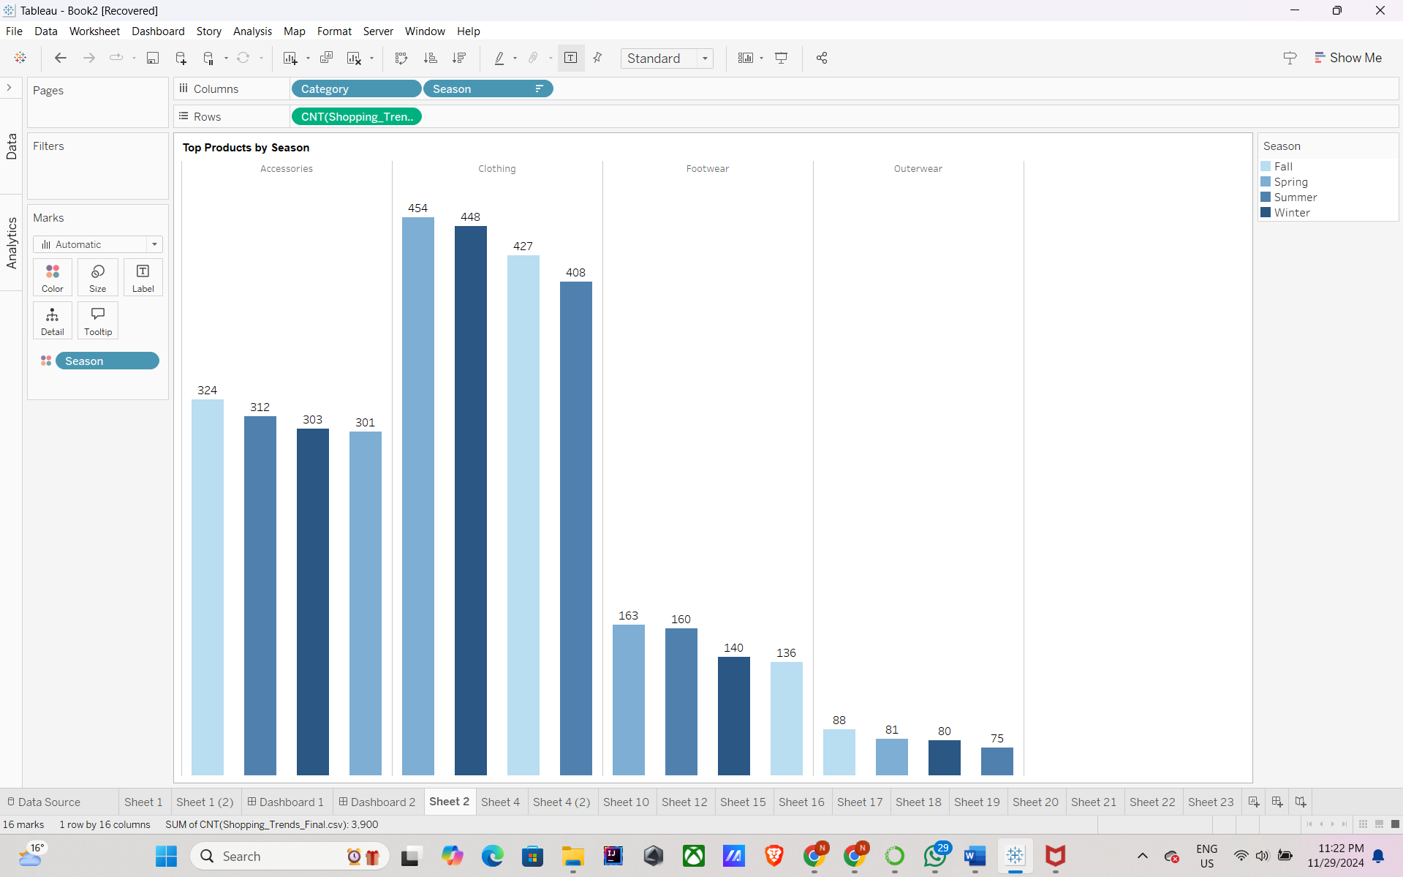

**PLOT 3: "Regional Sales Contributions"**

**Chart Type**: Geographic Map  
**Rows**: Latitude  
**Column**: Longitude  
**Marks Color Card**: SUM (Purchase Amount(USD))  
**Pre-attentive Attributes**: Geographic Position, Color Intensity  
**Color Distribution**: Gradient (Light Blue to Dark Blue)  
**Description**: Addresses Question 3 by visualizing regional contributions to total sales.  
**Connected Questions**: 3

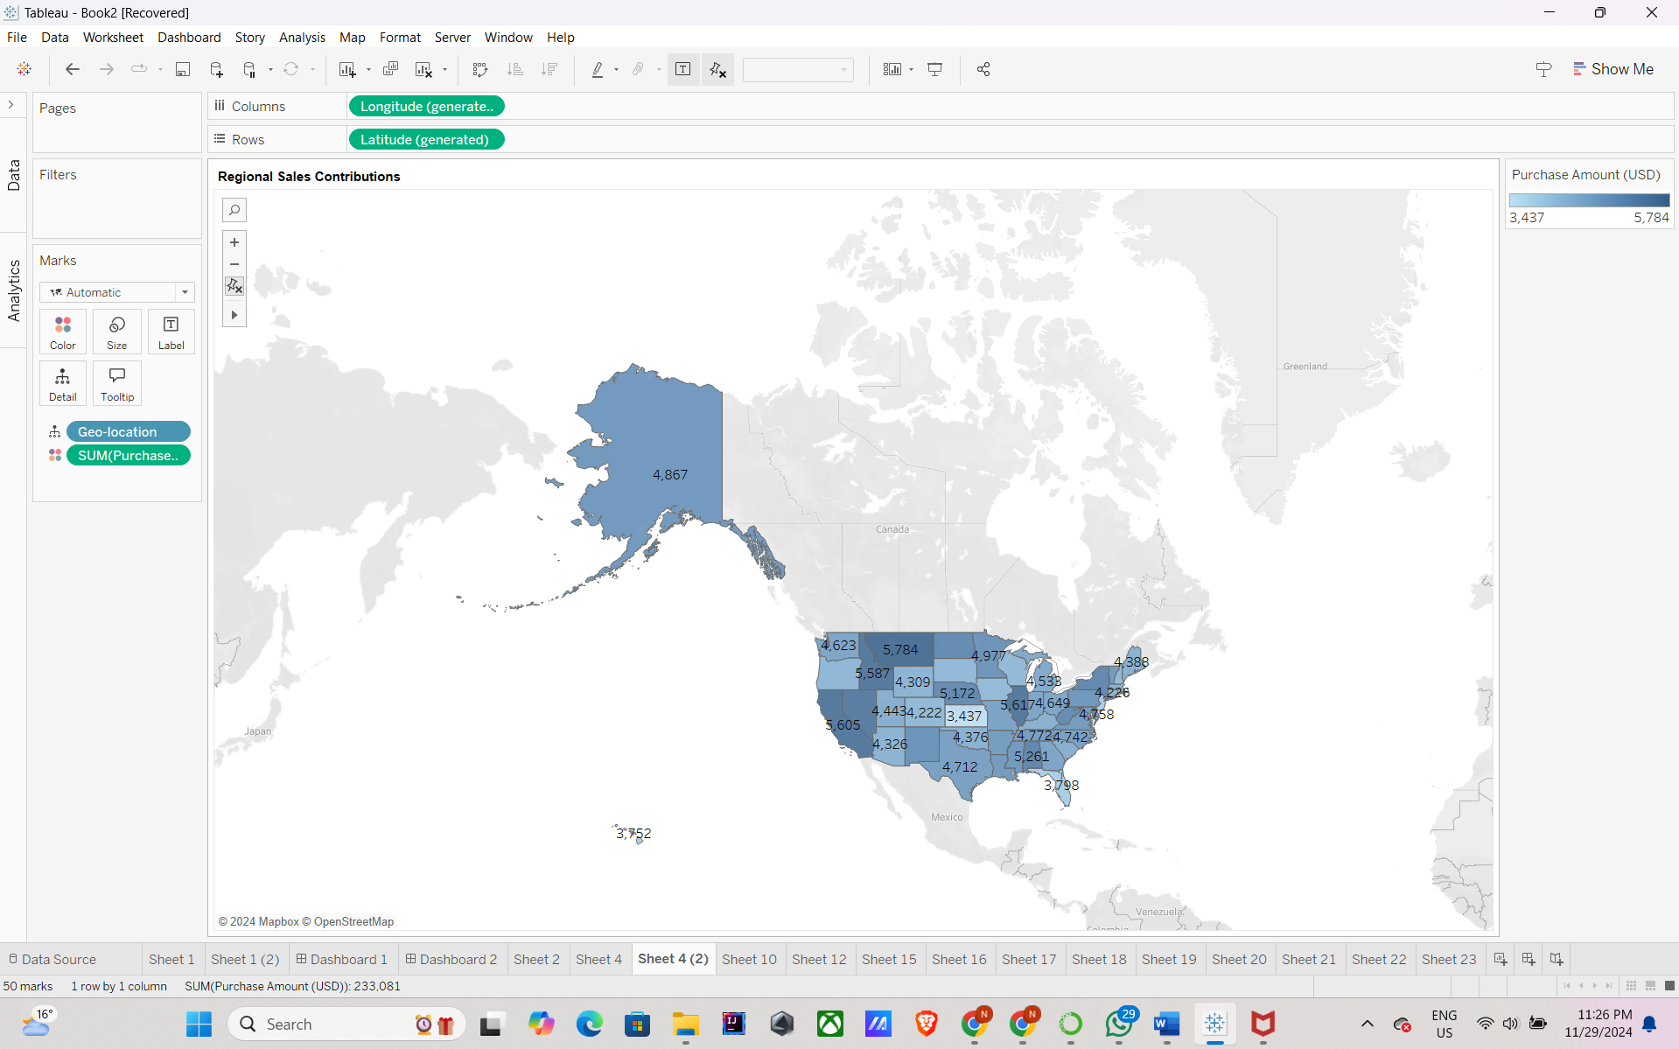

**PLOT 4: "Best Products by Feedback"**

**Chart Type**: Stacked Bar Chart  
**Rows**: AVG(Review Rating)  
**Column**: Item Purchased  
**Filters**: Top Rated Products (Parameter), Filter Top Ratings (Calculated Field)  
**Pre-attentive Attributes**: Length  
**Description**: Addresses Question 4 by ranking products based on customer feedback, segmented into best categories.  
**Connected Questions**: 4

**Changes done as Professor suggested:** Ordered the graphs in descending order and in the edit, axis set Include zero to false so that the axis does not start from 0 and difference between the element values are more visible.

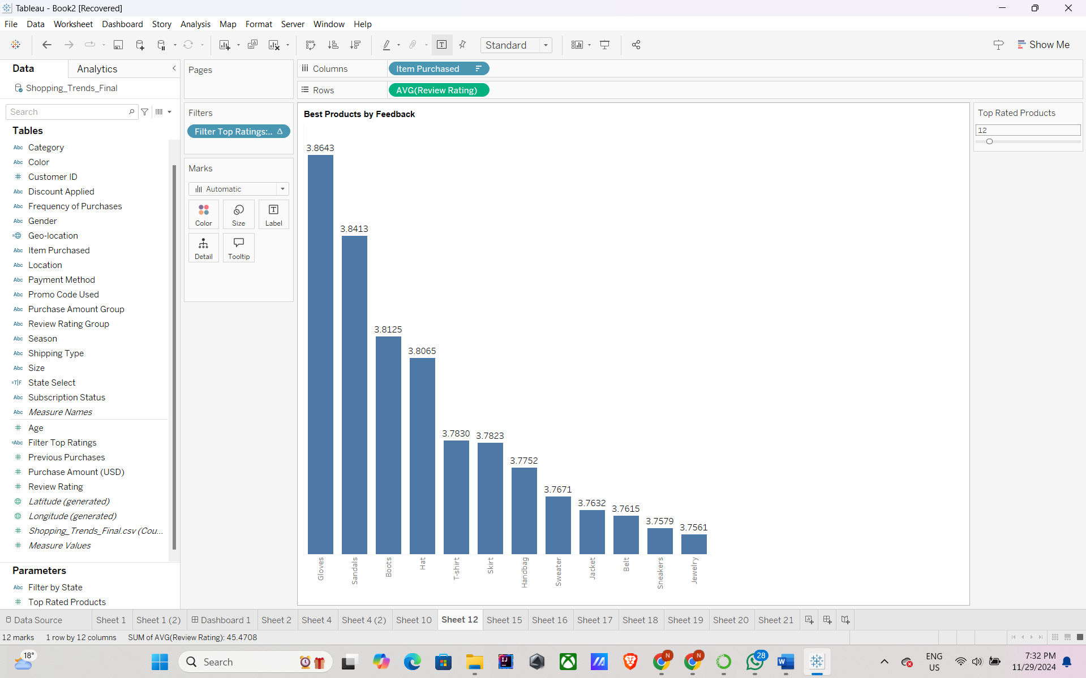

**PLOT 5: "Payment Method Preferences"**

**Chart Type**: Bar Chart  
**Rows**: COUNT(Transactions)  
**Column**: Payment Method  
**Pre-attentive Attributes**: Length, Stack Position, Color  
**Description**: Addresses Question 5 by visualizing the popularity of payment methods across all regions.  
**Connected Questions**: 5

**Changes done as Professor suggested:** Ordered the graphs in descending order and in the edit, axis set Include zero to false so that the axis does not start from 0 and difference between the element values are more visible.

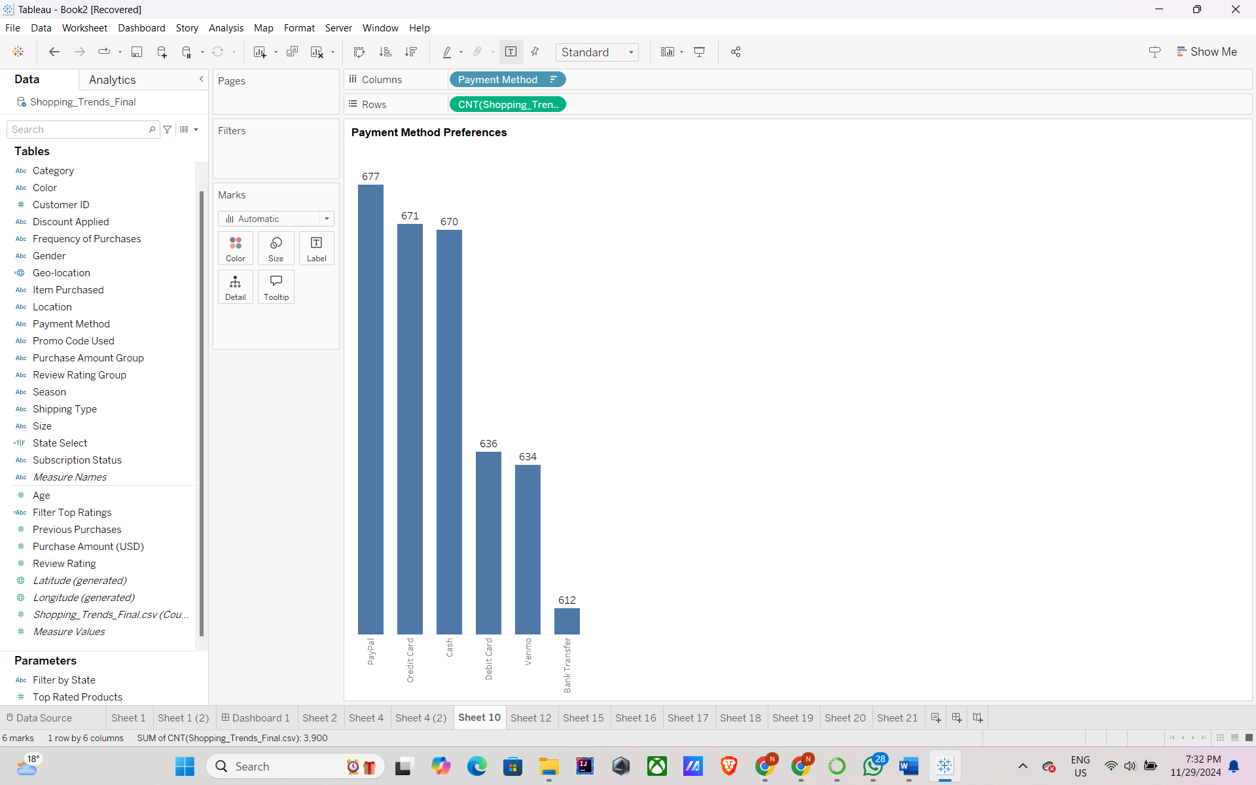

**PLOT 6: "Spending patterns by Age Group and Gender"**

**Chart Type**: Highlighted Table  
**Size**: SUM (Purchase Amount (USD))  
**Color**: Gender  
**Columns:** Age Group

**Rows**: Gender  
**Pre-attentive Attributes**: Size, Color  
**Color Distribution**: Distinct colors for each Gender  
**Description**: Addresses Questions 6, 13 and 14 by showing spending pattern across age groups and Gender  
**Connected Questions**: 6, 13 and 14

**Changes done as Professor suggested:** the graph from bubble chart to Highlighted table.

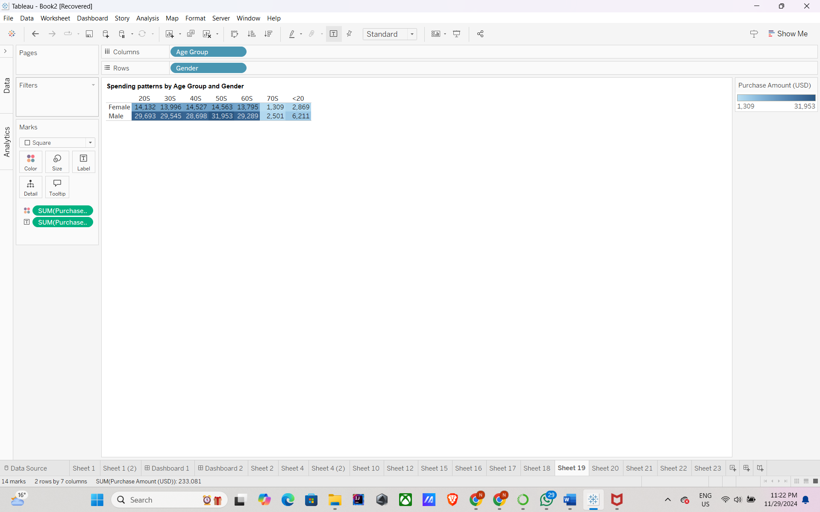

**PLOT 7: "Gender-Based Product Preferences"**

**Chart Type**: Stacked Bar Chart  
**Rows**: COUNT (Item Purchased)  
**Column**: Item Purchased  
**Marks Color Card**: Gender  
**Pre-attentive Attributes**: Length, Position, Color  
**Color Distribution**: Male (Orange), Female (Blue)  
**Description**: Addresses Question 7 by highlighting the highest-selling products for each gender.  
**Connected Questions**: 7

**Changes done as Professor suggested:** Ordered the graphs in descending order

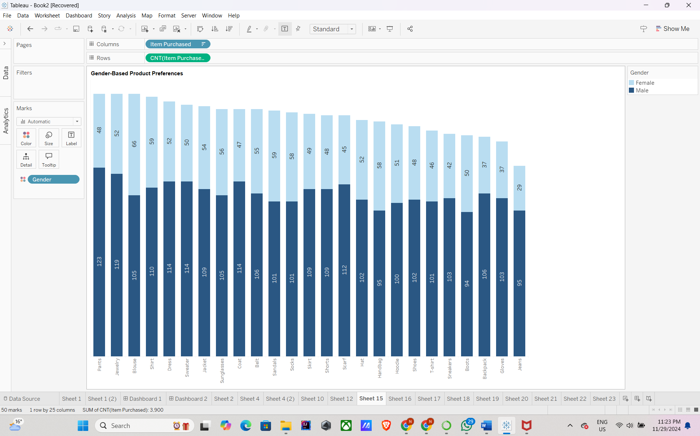

**PLOT 8: "Shipping Preferences for High-Value Purchases"**

**Chart Type**: Grouped Bar Chart  
**Rows**: CNT (Shopping_Trends_Final.csv)  
**Column**: Shipping Type, Purchase Amount Group

**Marks Color Card**: Purchase Amount Group  
**Pre-attentive Attributes**: Length

**Color Distribution**: Categorical colors for different Purchase Amount Group  
**Description**: Addresses Question 8 by showing preferred shipping types for high-value purchases.  
**Connected Questions**: 8

**Changes done as Professor suggested:** Ordered the graphs in descending order

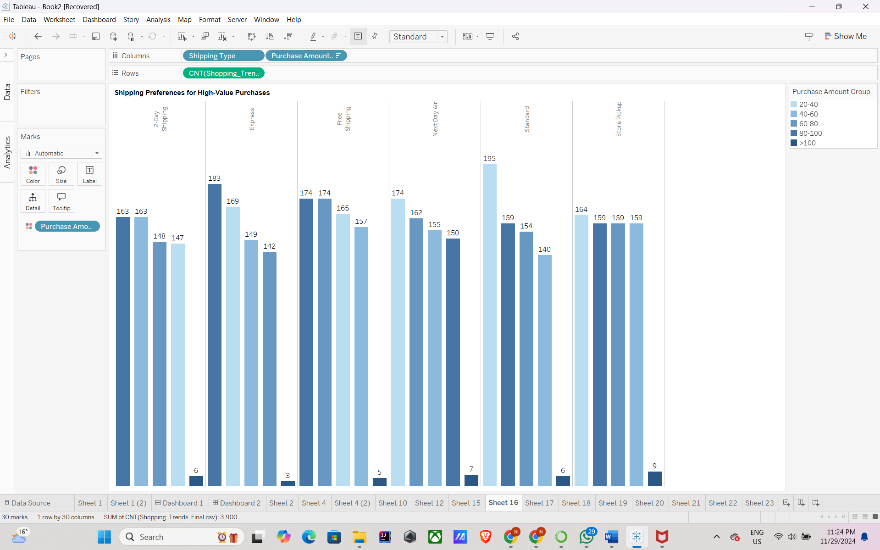

**PLOT 9: "Subscription-Based Customers by State"**

**Chart Type**: Stacked Bar Chart  
**Rows**: CNT(Shopping_Trends_Final.csv)  
**Column**: Location  
**Marks Color Card**: Subscription Status  
**Pre-attentive Attributes**: Length, Color  
**Color Distribution**: Subscription Status - Yes (Orange), No (Blue)  
**Description**: Addresses Question 9 by visualizing states with the highest subscription-based customers.  
**Connected Questions**: 9

**Changes done as Professor suggested:** Ordered the graphs in descending order

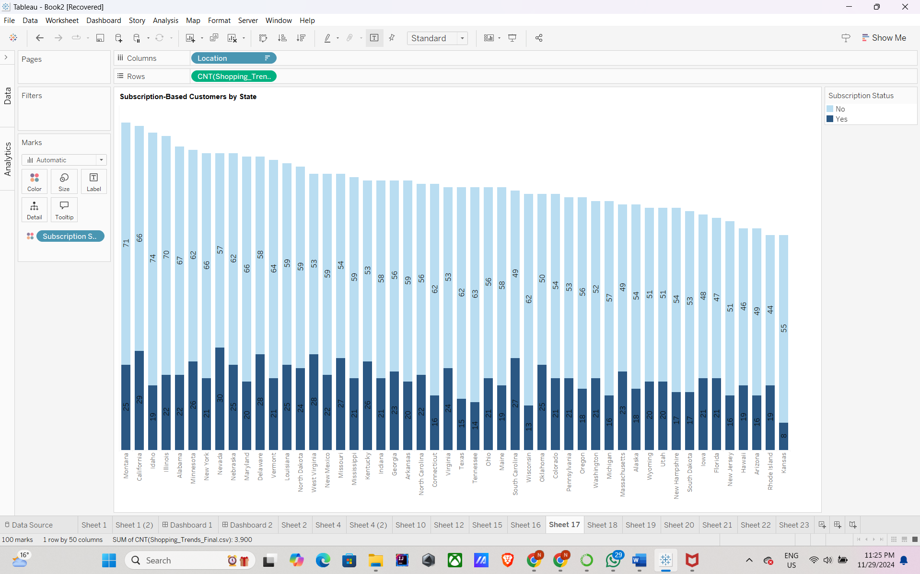

**PLOT 10: "Purchase Frequency Analysis"**

**Chart Type**: Line Chart  
**Rows**: SUM (Purchase Amount (USD))  
**Column**: Frequency of Purchases  
**Marks Color Card**: Review Rating Group  
**Pre-attentive Attributes**: Line Length, Position, Color  
**Color Distribution**: categorical colors for review ratings.  
**Description**: Addresses Questions 10, 11 and 15 by analyzing the relationship between purchase frequency, amounts and review ratings.  
**Connected Questions**: 10, 11, 15

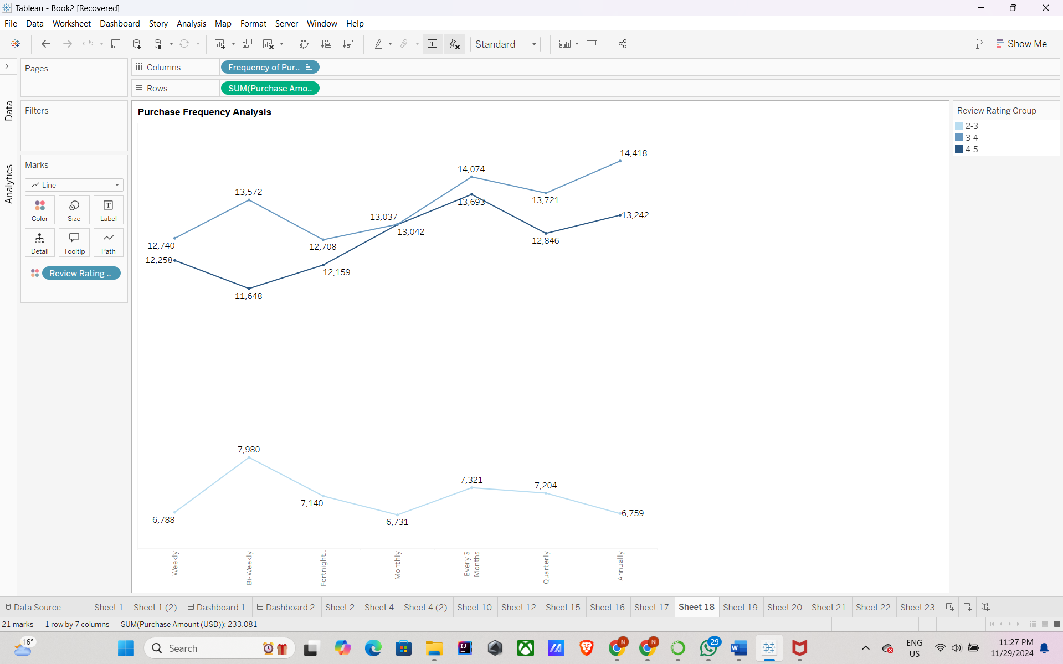

**PLOT 11: "Customer Spending Patterns by Purchase Count Group and Gender"**

**Chart Type**: Highlighted Table  
**Size**: CNT (Shopping_Trends_Final.csv)  
**Color**: Gender  
**Columns:** Purchase Amount Group,

**Rows**: Gender  
**Pre-attentive Attributes**: Size, Color  
**Color Distribution**: Distinct colors for each Gender  
**Description**: Addresses Questions 12 by visualizing spending patterns for customers with varying purchase counts and gender segmentation.  
**Connected Questions**: 12

**Changes done as Professor suggested:** Changed the graph from bubble chart to Highlighted table.

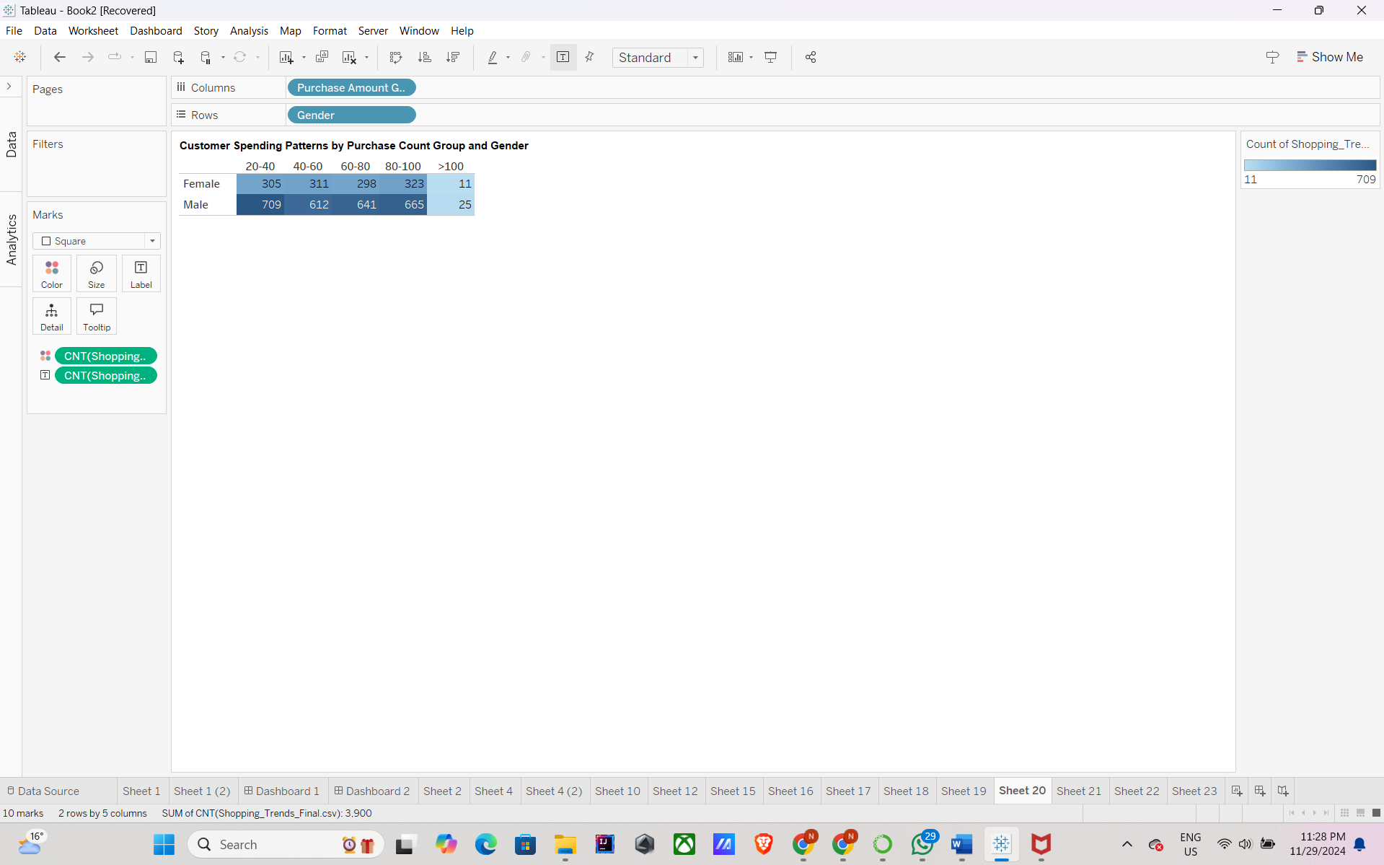

**SECTION 6:**

**List of Interactive Controls**

The following interactive controls will allow users to customize the visualizations and extract meaningful insights from the dashboard:

**State Select Dropdown**

* **Purpose**: Allows users to filter data by specific states or view data for all states.
* **Connected Plots**:
  + Plot 1: "Revenue by Product Category for a Given Location"
  + Plot 3: "Regional Sales Contributions"
  + Plot 9: "Subscription-Based Customers by State"
* **Value Range**: List of unique states from the dataset. Includes "All States" as an option.
* **Loaded From**: Location attribute in the dataset.

Created a parameter “Filter by State” to filter the revenue based on the state selected.

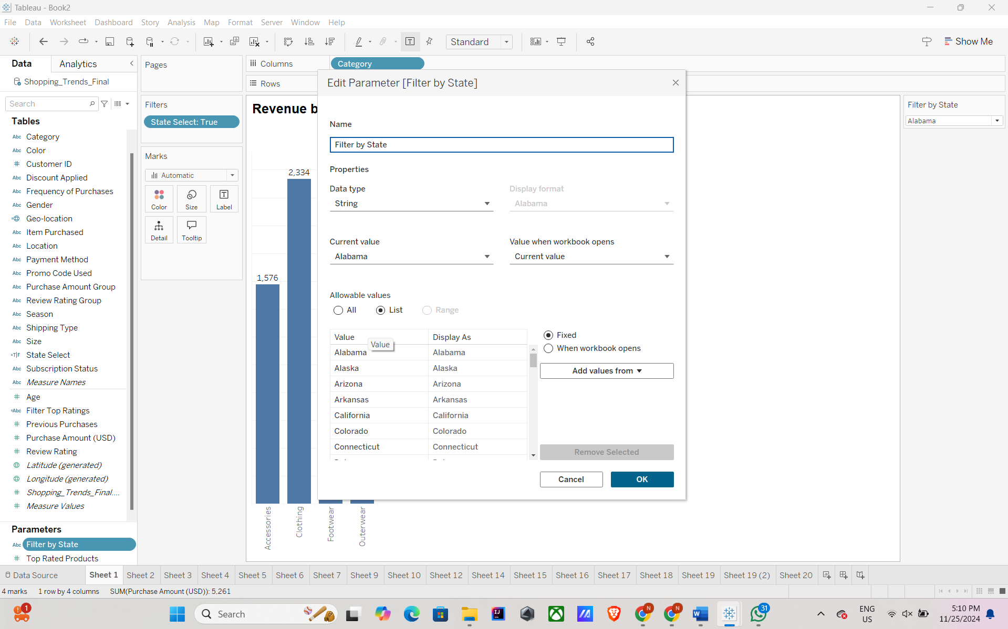

For this we created a calculated field State Select to filter and display only the states selected by the user in “Filter by State” drop down.

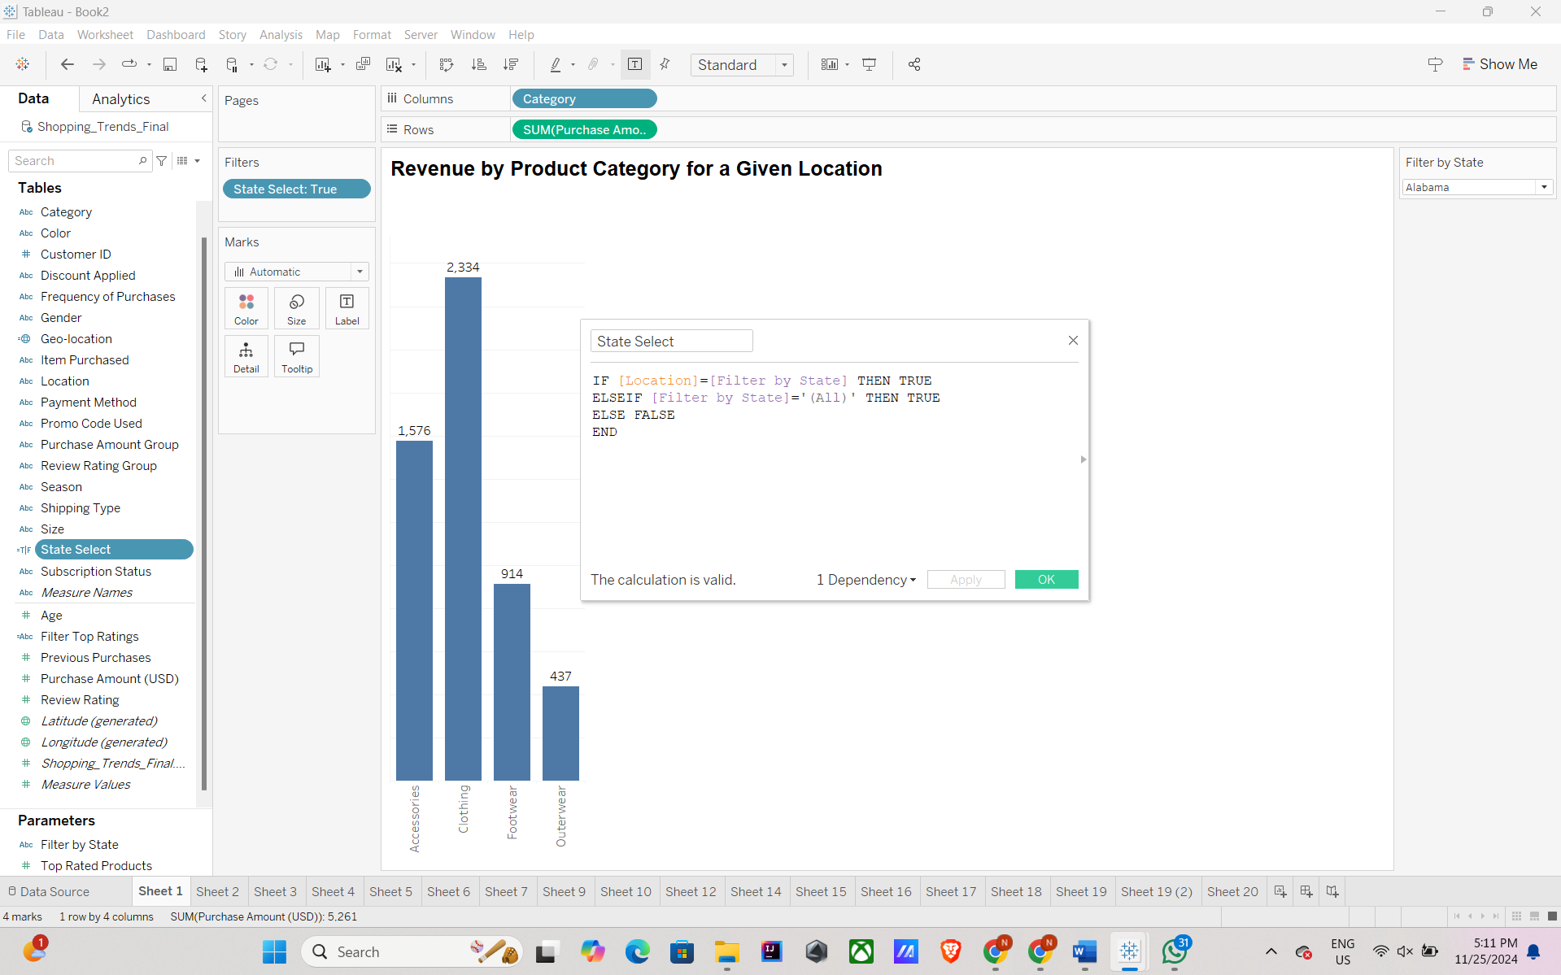

**Top Rated Products Parameter**

* **Purpose**: Filters the top x products based on review ratings
* **Connected Plots**:
  + Plot 4: "Best Products by Feedback"
* **Value Range**: Numeric range from 1 to 100 (but actually corresponds to number of products available).

Below is the screenshot for the “Top Rated Products” parameter created.

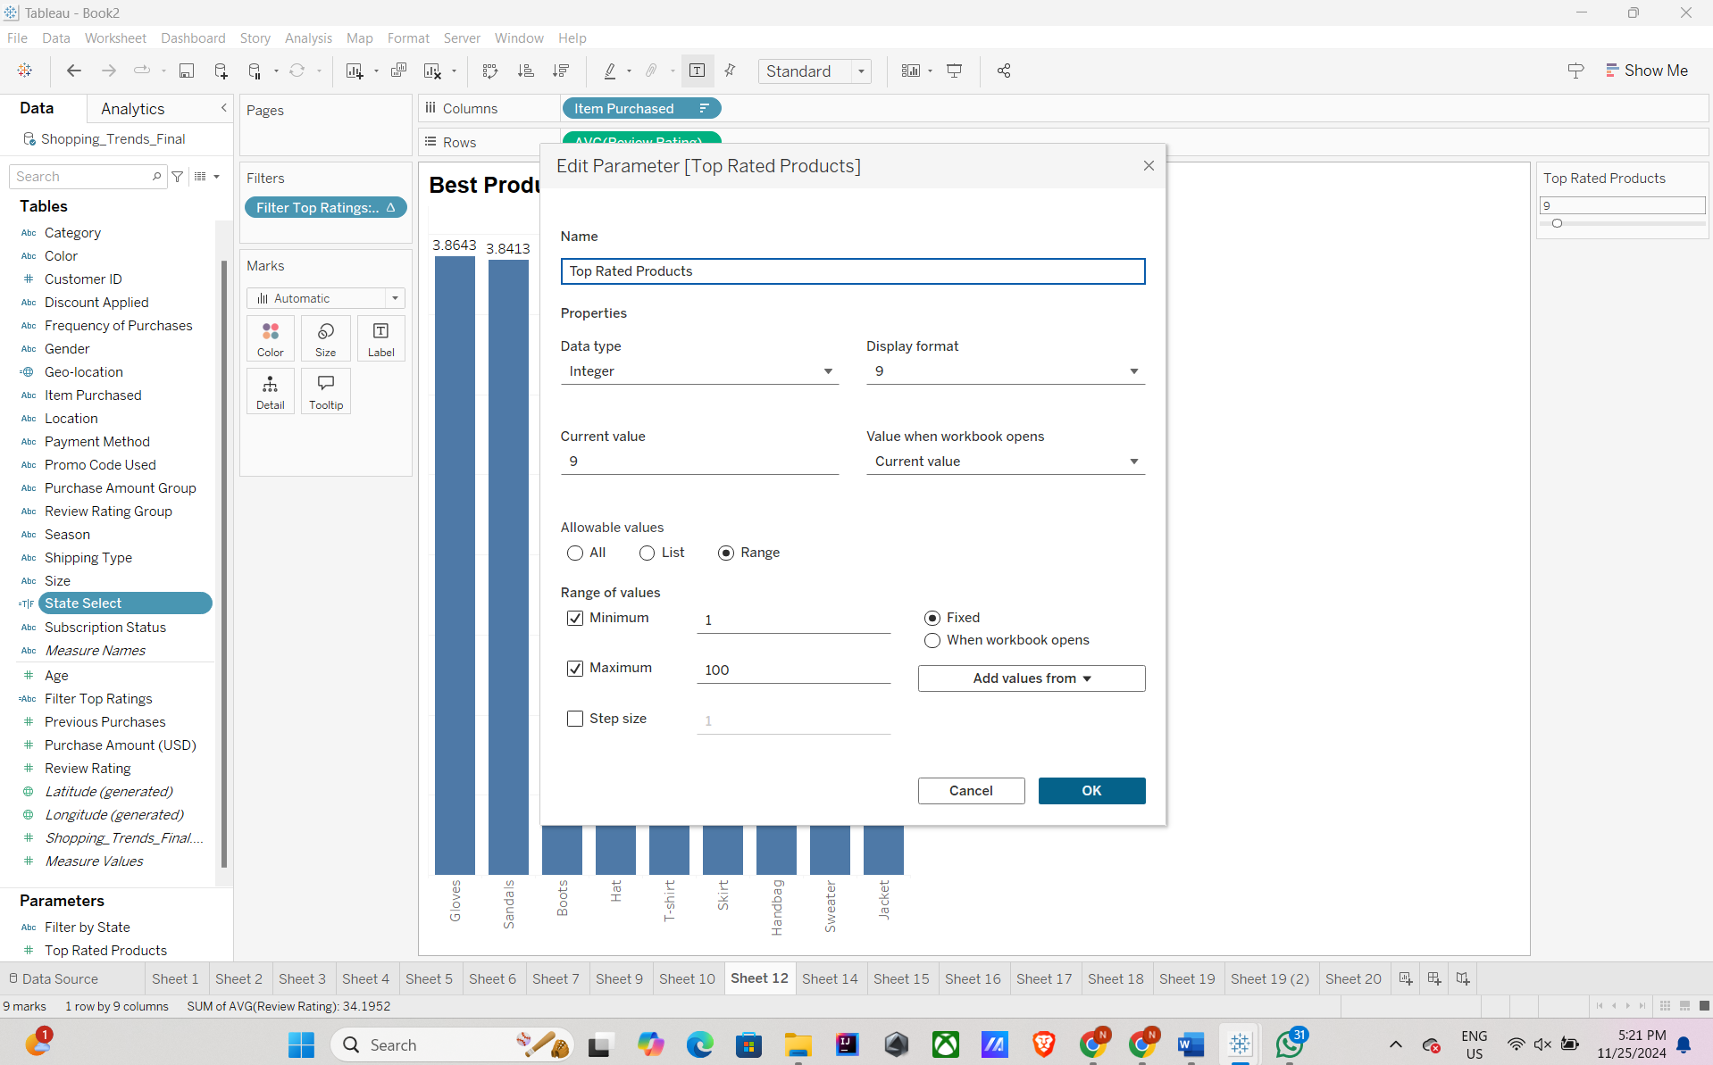

Below is the screenshot for the “Filter Top Ratings” calculated field created to filter the top x ratings selected from the “Top Rated Products” parameters.

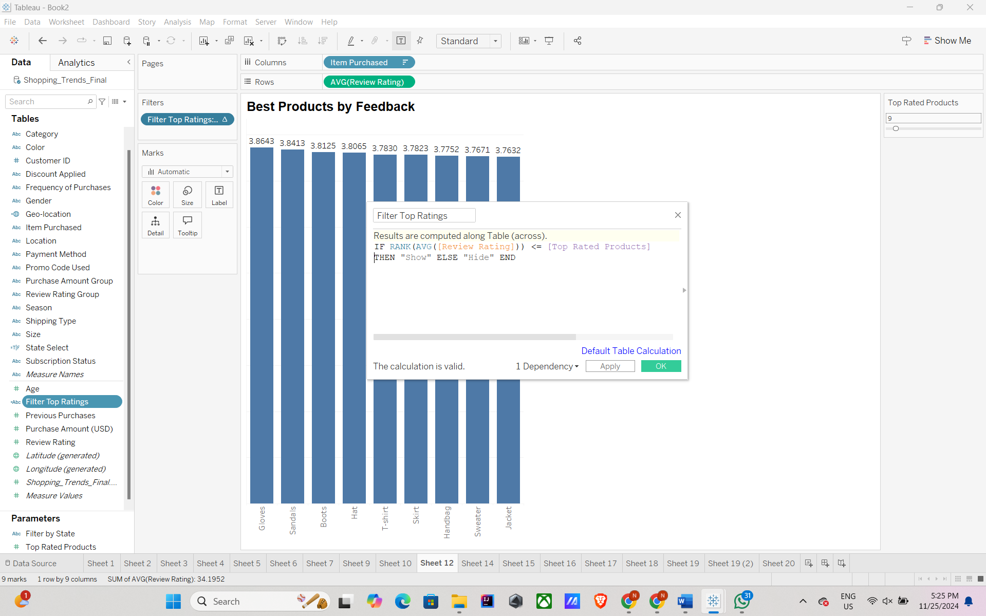

**Gender Filter**

* **Purpose**: Filters data by gender to analyze product preferences or spending patterns.
* **Connected Plots**:
  + Plot 6: "Spending Patterns by Age Group and Gender"
  + Plot 7: "Gender-Based Product Preferences"
  + Plot 11: "Customer Spending Patterns by Purchase Count"
* **Value Range**: Male, Female.
* **Loaded From**: Gender attribute in the dataset.

Created a parameter “Filter by Gender” to filter the data on all the plots based on the gender selected.

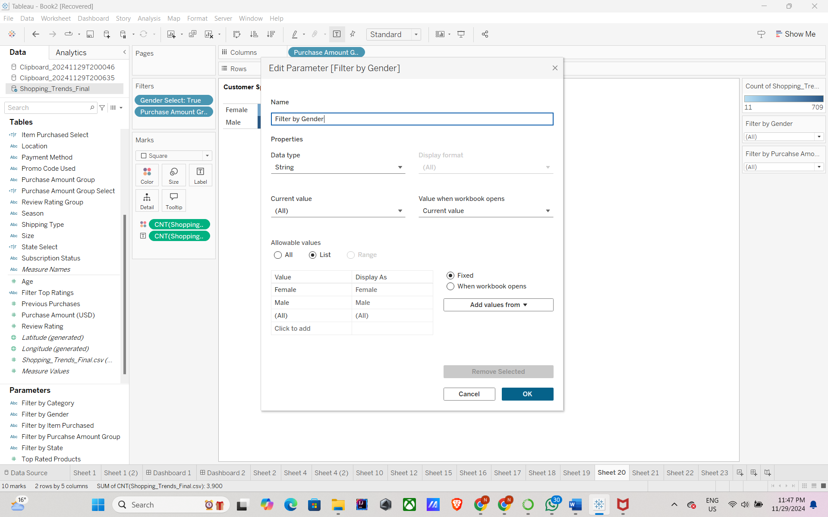

For this we created a calculated field “Gender Select” to filter and display only the gender selected by the user in “Filter by Gender” drop down.

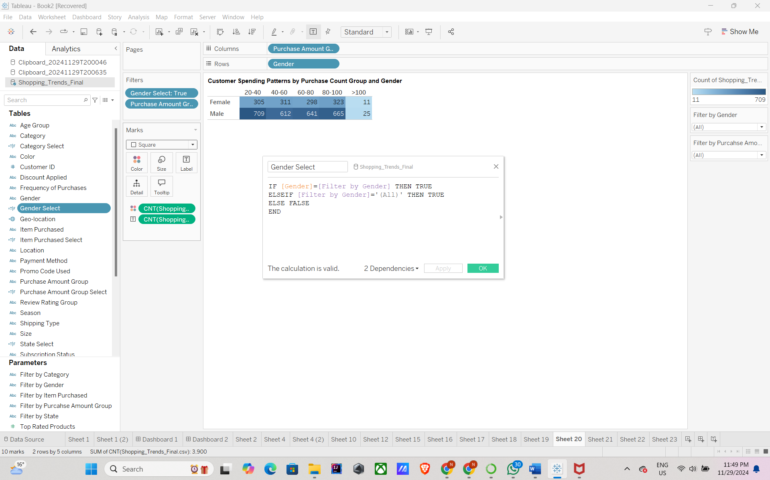

**Purchase Amount Group Selector**

* **Purpose**: Filters data by purchase value ranges for detailed analysis.
* **Connected Plots**:
  + Plot 8: "Shipping Preferences for High-Value Purchases"
  + Plot 11: "Customer Spending Patterns by Purchase Count"
* **Value Range**: Defined purchase amount groups (e.g., 20-40, 40-60, 60-80, 80-100, 100+).
* **Loaded From**: Purchase Amount Group Column calculated field created using Purchase Amount.

Created a parameter “Filter by Purchase Amount Group” to filter the data on all the plots based on the purchase amount group selected.

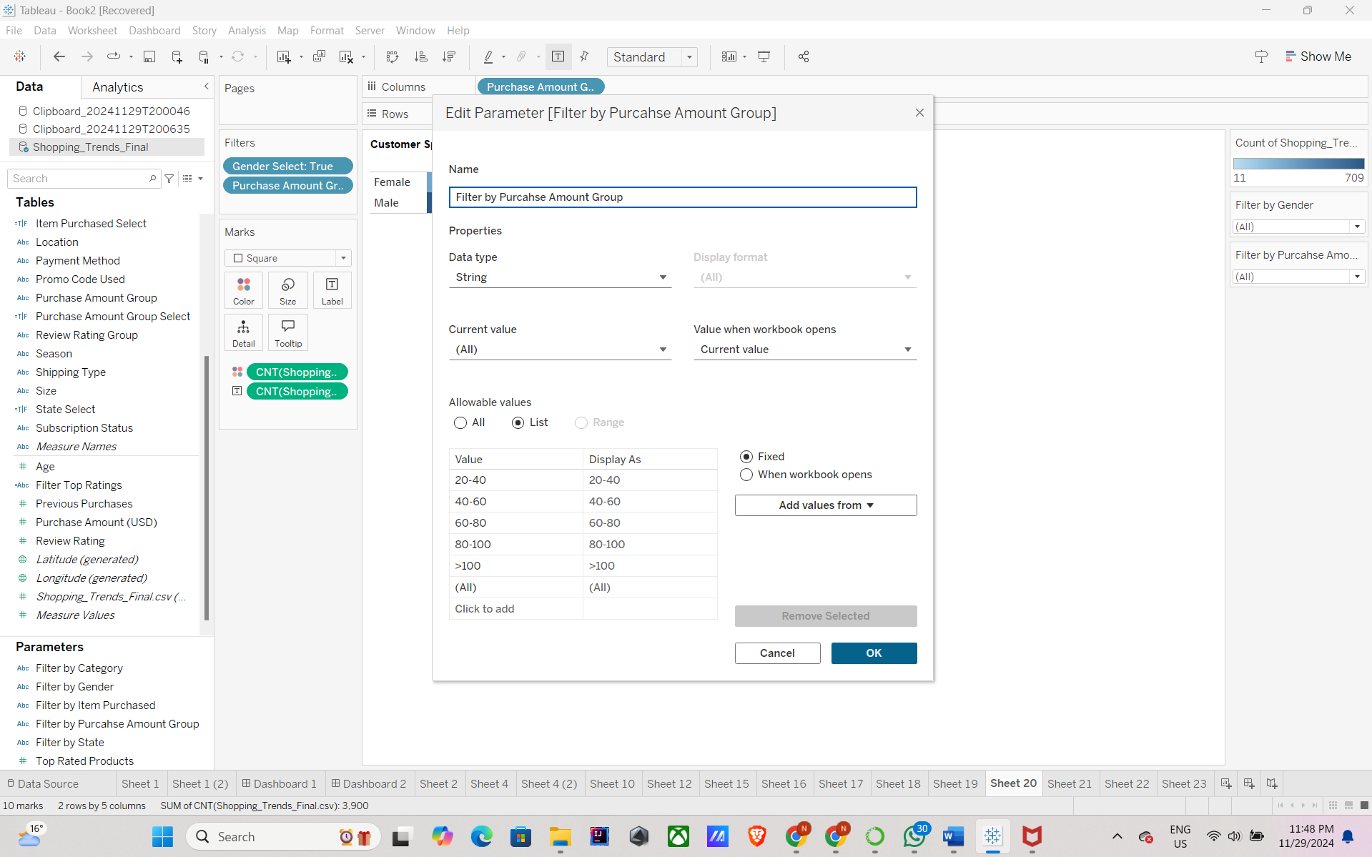

For this we created a calculated field “Purchase Amount Group Select” to filter and display only the purchase amount group selected by the user in “Filter by Purchase Amount Group” drop down.

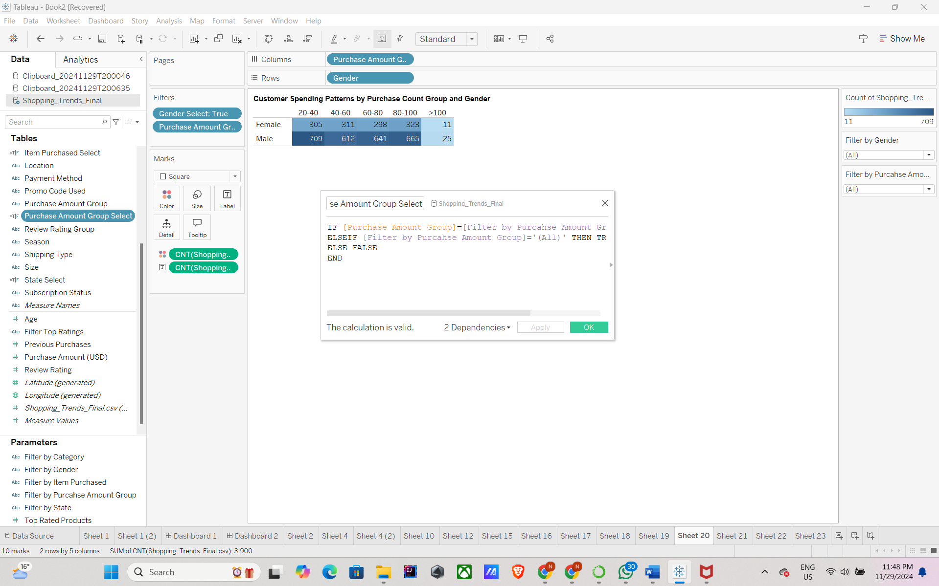

**Category Selector Dropdown**

* **Purpose**: Allows users to filter and analyze data for specific product categories.
* **Connected Plots**: Filter to filter all the data in the dashboard based on the category filter selected. This is to individually analyze the revenue based on category. All the plots are connected to this filter.
* **Value Range**: List of unique categories present in the dataset.
* **Loaded From**: Category attribute in the dataset.

Created a parameter “Filter by Category” to filter the data on all the plots based on the category selected.

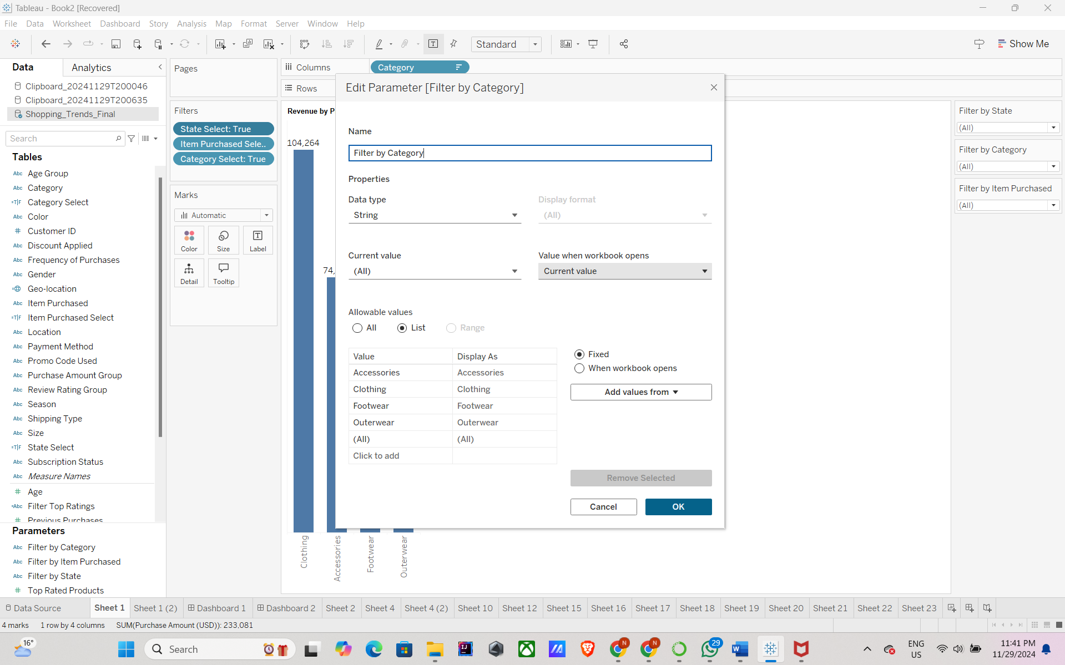

For this we created a calculated field Category Select to filter and display only the categories selected by the user in “Filter by Category” drop down.

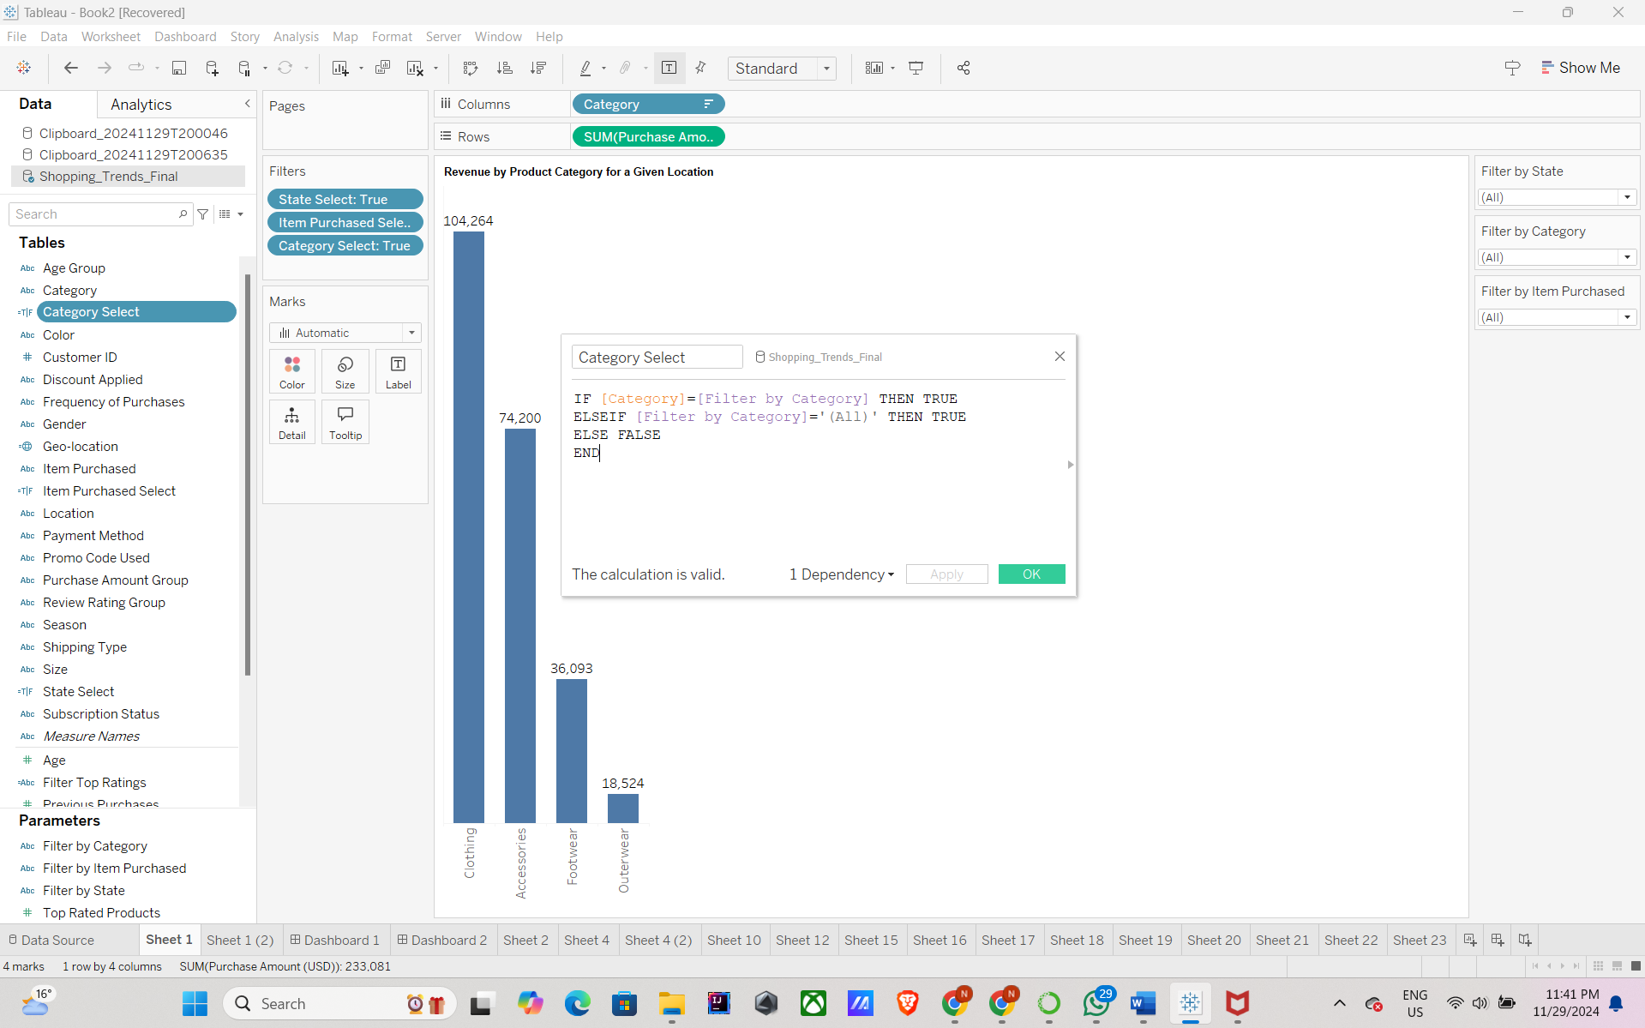

**Item Purchased Selector Dropdown**

* **Purpose**: Enables users to focus on specific items purchased for detailed feedback and analysis.
* **Connected Plots**: Filter to filter all the data in the dashboard based on the item purchased filter selected. This is to individually analyze the revenue based on items purchased. All the plots are connected to this filter.
* **Value Range**: List of unique items purchased in the dataset.
* **Loaded From**: Item Purchased attribute in the dataset.

Created a parameter “Filter by Item Purchased” to filter the data on all the plots based on the item purchased selected.

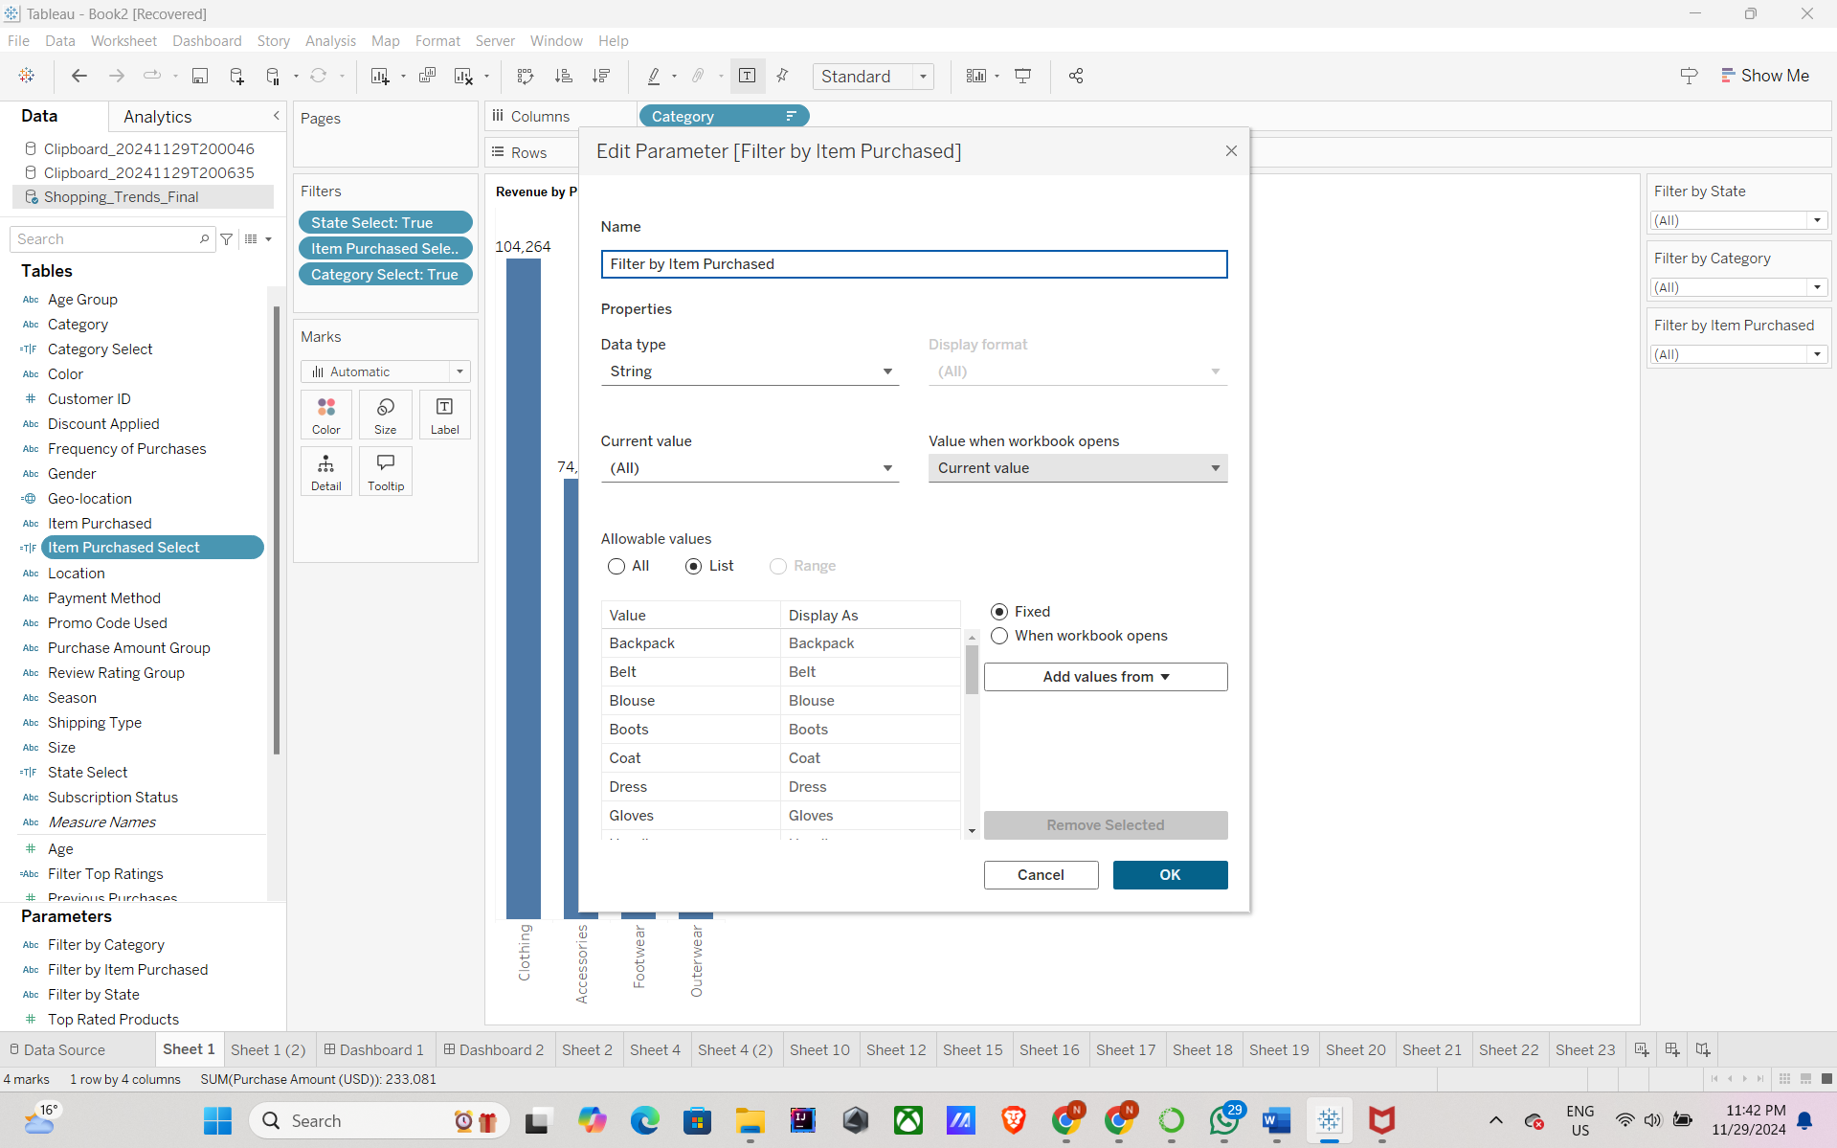

For this we created a calculated field Item Purchased Select to filter and display only the items purchased selected by the user in “Filter by Item Purchased” drop down.

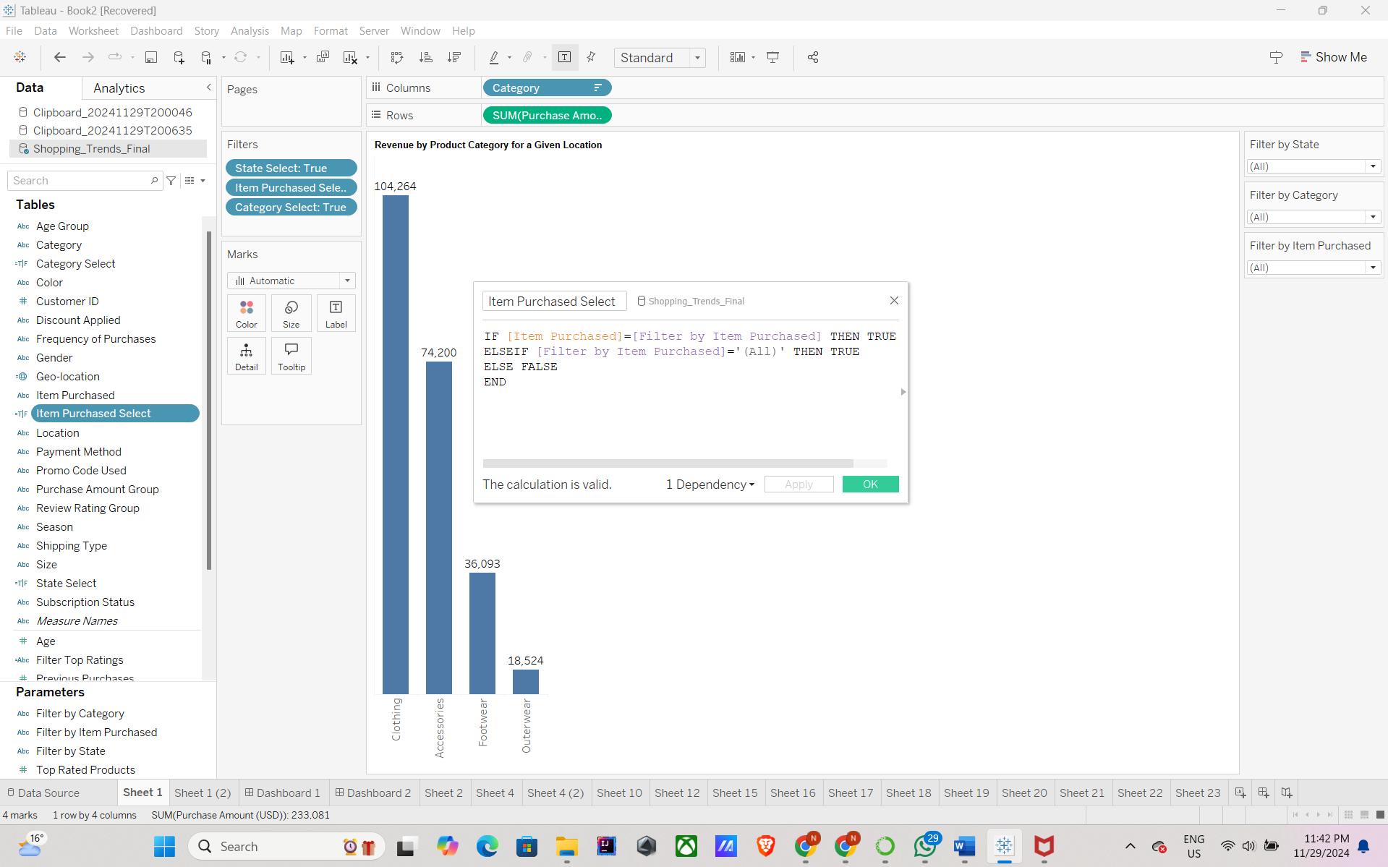

These controls enhance interactivity, enabling users to explore the data across multiple dimensions and extract insights tailored to their interests.

**Section 7: References**

1. Sourav Banerjee. *Customer Shopping Trends Dataset*. Kaggle, 2024, <https://www.kaggle.com/datasets/iamsouravbanerjee/customer-shopping-trends-dataset>
2. Mural Board Link: <https://app.mural.co/t/project373258/m/project373258/1731619110561/91ce729475358157ad3ba50e93d507db527e9d4c>
3. Final Dashboard Link:

<https://public.tableau.com/app/profile/naveen.kumar.manokaran/viz/FinalDashboard_17330800588460/Dashboard1?publish=yes>